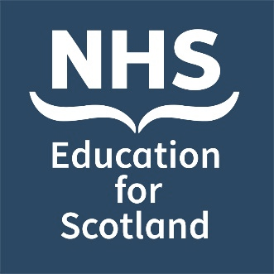
Date: Tuesday 3 December 2024
NES Bereavement Education Conference 2024
Poster Abstract Submission Form
Venue: Virtual

Invitation: You are invited to submit poster abstracts for the NHS Education for Scotland (NES) virtual bereavement education conference:

Bereavement in the modern world: Kindness in the chaos

#NESBereavement2024

NES is very pleased to be hosting its fifth bereavement education conference on 3 December 2024. This one-day event will be relevant to all health and social care staff.

Submissions are welcome from those working within Scotland and internationally, and from all sectors including health and social care services, integration authorities, voluntary and partner organisations and other public or private sector organisations.

Poster categories: We invite submissions of poster abstracts covering any aspect of innovation and creativity leading to improved outcomes:
- for those who are bereaved and / or
- for staff who experience death and bereavement in the course of their work.

These may include aspects of education, service delivery and quality improvement relevant across a wide spectrum of bereavement related situations. We are also happy to accept work that has already been presented at other events.

Abstract template: Please use the abstract template on the following page to complete your submission and send your completed form to events@nes.scot.nhs.uk.

Please also direct any queries or requests for further information to the email address noted above.

Key dates:

Deadline for poster abstract submissions | Monday 7th October at 12 noon BST
Lead authors will be notified whether their abstract has been selected | Monday 21st October

Poster title
Lead Author details: | Name:
 | Job title:
 | Organisation:
 | Email address (Please provide a work email address where possible):
Affiliation / institution where the work has been carried out:
Details of co-author(s) – please include, name, job title, organisation:
Authors of successful abstract submissions will have their poster published on the NES Support Around Death website and they may also be posted on our social media channels.  Please select yes / no to confirm whether or not you agree to your poster being published in these ways. |  | Yes ❒
 |  | No ❒

Abstract text (300-word limit) – You may find it useful to utilise the following structure (Introduction, Methods, Results / Discussion, Conclusion) but this is not mandatory.

Please email your completed form to events@nes.scot.nhs.uk no later than 12 noon BST on Monday 7th October.

We would hope to contact you within 2 weeks of the closing date. Further details will then be forwarded to authors of successful abstracts.

Further information about the conference can be found at https://www.nes.scot.nhs.uk/events

