
AHP Projects Progressing PrBL
Orthoptics

Sarah Brown, 2025

Situation / Background to project
There is a positive trend in the increasing number of orthoptic undergraduate students studying in Scotland, with intakes at Glasgow Caledonian University (GCU) of 8 students in 2022/23, 28 in 2023/24 and 35 in 2024/25. There is an ongoing need to ensure sufficient placement capacity and practice educator capability through using different models of Practice-based Learning (PrBL) to provide high quality clinical education for the increasing numbers of students.

Purpose
To increase orthoptic PrBL capacity in Scotland through the implementation and spread of different models of placement delivery and demonstrate the impact of different models of PrBL on orthoptic students practice-based learning.

Scope of project
In Scope | Out of Scope
- PrBL experiences in Scotland for GCU orthoptic undergraduates  - Practice educators in NHS Scotland  - Simulation models of PrBL  - Different modes of PrBL, eg Blended, digital and face to face | - PrBL experiences out with Scotland  - Practice educators out with NHS Scotland  - Models of practice-based learning other than those in scope

Identification of stakeholders
- Orthoptic PrBL Stakeholder Group
- Glasgow Caledonian University BSc (Hons) Orthoptics Programme Lead and Placement Lead
- Scottish Orthoptic Heads of Service Group (SOHOS)
- NES AHP PrBL Practice Education Leads (PELs)
- 4th year Orthoptic undergraduates

Task
To build on the successes of the Orthoptic PrBL Project Phases 1 and 2, implementing and spreading specific models of PrBL within orthoptic undergraduate education in Scotland.

Objectives
- Develop and incorporate the simulation elements of the Stroke PrBL Programme tested in Phase 2 of the Orthoptic PrBL Project, into a 4-week Peer Enhanced e-Placement (PEEP).
- Build the capability of orthoptic practice educators, through education and training, to effectively deliver simulation and facilitate learning of orthoptic students on the PEEP.
- Demonstrate the impact of the use of the simulation model of PrBL on orthoptic student’s learning.
- Explore the use of simulation PrBL for other complex ocular motility conditions.

Key achievements
- Developed and tested a 6-session programme of simulation-based learning, providing an additional 126 hours of clinical education for a cohort of 4th year orthoptic students.
- Recruited a team comprising appropriate clinical and educational expertise to deliver simulation-based learning events.
- Established and maintained a psychologically safe learning environment for students throughout the duration of the programme.
- Designed a 4-week PEEP programme which can incorporate simulation-based learning events as required.

Actions
- Designed and delivered a programme of simulation-based learning ensuring:
  - Learning opportunities encompassed a range of technical and non-technical clinical skills (Appendix 1).
  - Recognised structure and tools for simulation-based learning were used.
  - Clear links to the clinical practice education and relevant academic modules of the GCU BSc (Hons) Orthoptics programme.
- Recruited a multi-professional team of educators comprising orthoptic practice educators (NHS Greater Glasgow and Clyde – South Sector and NHS Lanarkshire); NES AHP PEL (Orthoptics); GCU Programme Lead (Orthoptics) and GCU lecturer (Optometry).
- Identified educational resources for educators to increase their knowledge and skills in simulation-based education prior to delivering the programme.
- Identified existing self-assessment, reflective practice and evaluation tools for students and educators.
- Designed a 4-week PEEP programme, blending with the simulation programme for future use.
- Shared the learning from the orthoptic project with orthoptic and AHP stakeholders.

Impact
The orthoptic project objectives have been met and the impact of actions are:
Service Impact
- 100% (n7) of 4th year orthoptic students had access to a newly designed programme of simulation-based learning, providing an additional 126 hours of clinical practice education.
- 86% of students attended the full programme.
Performance Impact
- A 6-session simulation programme was delivered in November/December 2024 by a multi-professional team of orthoptic practice educators, vision science lecturers and service users.
- Increased student’s exposure to both people with complex ocular motility disorders and NHS board orthoptic practice educators with specialist knowledge and advanced practice in such areas.
- Increased student’s exposure to a range of learning covering both technical and non-technical clinical skills.
Education impact
100% (n7) of students responded to the simulation programme evaluation.
- 100% reported increased confidence in their technical and non-technical clinical skills following the programme.
- 100% identified new knowledge and skills acquired from the programme.
- 100% agreed the programme complemented the clinical practice education and relevant academic modules of the GCU BSc (Hons) Orthoptics programme.

75% (n 3) of orthoptic educators responded to the simulation programme evaluation and of these:
- 67% reported an increase in confidence to deliver a simulation-based learning event.
- 100% reported they are motivated or very motivated to participate in future simulation-based learning programmes for orthoptic undergraduates.
- Acquisition of new knowledge and skills was reported by 100% of practice educators delivering simulation-based learning events.
- 100% reported receiving direct feedback from the students and self-evaluation using the Debriefing Assessment for Simulation in Healthcare (DASH) | Center for Medical Simulation can be used for their own personal and professional development.
Engagement impact
100% (n7) of students responded to the simulation programme evaluation.
- 100% agreed that their learning from non-technical clinical skills simulation-based learning events (SBLE’s) can be applied on clinical placement.
- 86% agreed that their learning from technical clinical skills SBLE’s can be applied on clinical placement.
- 100% agreed working with orthoptic practice educators from NHS boards helped their learning.
- The programme received a rating of 4.9/5 stars and 100% of students would recommend it to others.

75% (n3) of orthoptic educators responded to the simulation programme evaluation and of these:
- 100% agreed the programme supports student practice-based learning needs when on placement.
- 100% would recommend participating in simulation-based learning to other practice educators.
- 100% of educators involved in the design and delivery of the simulation programme completed relevant modules of the NES Clinical Skills Managed Education Network (CSMEN) learning programme: Becoming a simulation-based educator.
At the end of each SBLE student opinions were gathered on whether a psychologically safe learning environment had been maintained during the event.
- 100% (n7) of students answered YES for 3 out of 4 SBLEs.
- For the remaining SBLE, 83% answered YES and 16% answered MAYBE.

Learning / Recommendations
- Embed simulation-based learning into orthoptic undergraduate education in Scotland as a bridge between academic and practice-based learning.
- Spread technical and non-technical clinical skills simulation-based learning to encompass both Years 2 and 3 orthoptic undergraduate education.
- To be responsive to placement capacity challenges in the future, GCU to develop their simulation-based orthoptic educator resource and NHS Boards to work collaboratively with GCU, releasing orthoptic practice educators to deliver simulation-based learning events at GCU.
- Simulation-based learning events:
  - Are designed and delivered collaboratively by a multi-professional team of academic and practice educators with relevant clinical subject-matter and educational expertise
  - Have service-users with lived-experience as core participants
  - Link clearly with academic and clinical practice education modules on the GCU BSc (Hons) Orthoptic course
- Upskilling orthoptic practice educators in the design and delivery of simulation-based learning, using the NES resources Becoming a Simulation based educator, Tiers 1 and 2 and the AHP Practice Educator Development Framework.

Appendix 1
Programme of simulation-based learning events (SBLE)
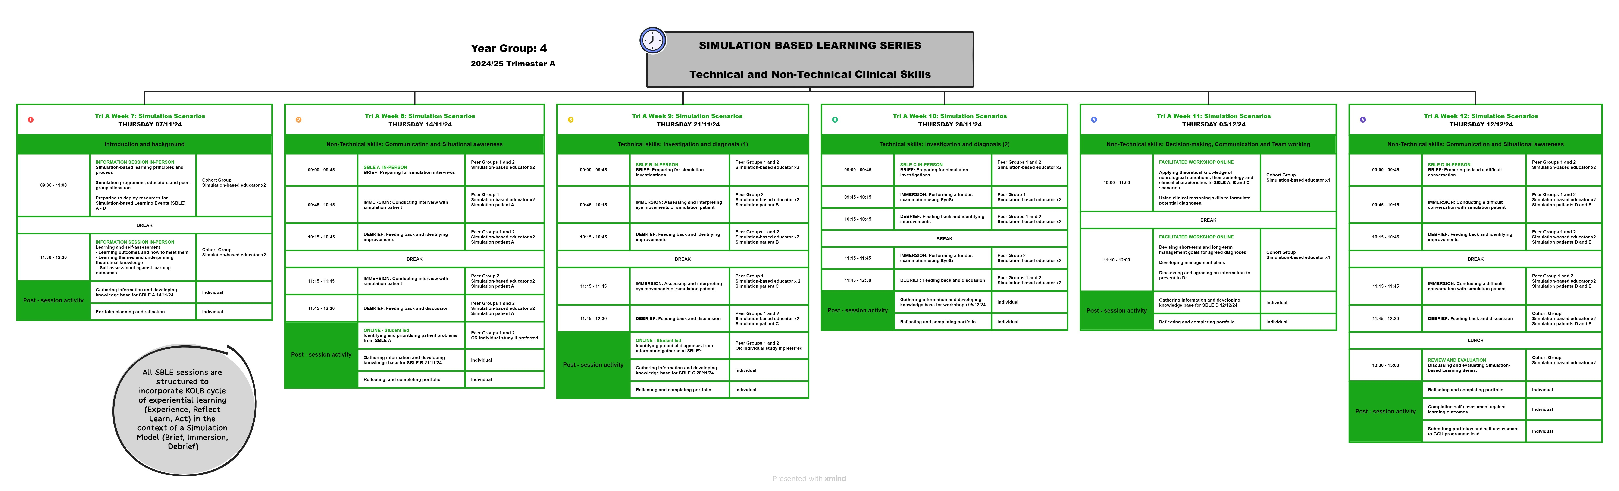


NHS Education for Scotland
Westport 102
West Port
Edinburgh EH3 9DN
tel: 0131 656 3200
www.nes.scot.nhs.uk
© NHS Education for Scotland 2024. You can copy or reproduce the information in this resource for use within NHSScotland and for non-commercial educational purposes. Use of this document for commercial purposes is permitted only with the written permission of NES.

This resource may be made available, in full or summary form, in alternative formats and community languages. Please contact us on 0131 656 3200 or email altformats@nhs.scot to discuss how we can best meet your requirements.

