
AHP Projects Progressing PrBL
Dietetics

Joanna Teece and Karin Massie, 2025

1.0 Situation/Background
The 2023 AHP Practice Based Recovery Dietetic report outlined key recommendations for Dietetic practice-based learning (PrBL). With 12 months of Scottish Government funding, this project aims to enhance and expand future opportunities.

Purpose
The purpose is to cultivate high-quality diverse PrBL for Dietitians of the future.

Objective
The objective is to review and advance recommendations from the 2023 AHP PrBL Recovery Dietetic report. These focused on building capacity via peer-assisted learning, a digital module for specialist areas and cross-sector PrBL.

Scope of project
The project scope will focus on enhancing Dietetic PrBL learning across various sectors, embedding Peer Assisted Learning (PAL), and developing digital modules for specialist areas, especially where recruitment and opportunities are lacking. In scope, is the learning recommendations from 2023 AHP PrBL recovery dietetic work, noting constraints of influence, within timescales of the project. Out of scope is post-registration Dietetic education, British Dietetic Association (BDA) UK Common Assessment Tool. and the NHS Education for Scotland PrBL partnership agreements and apportionment .

Identification of stakeholders
The 2023 PrBL Dietetic stakeholder group had not been maintained. A launch event in July 2024 brought together Dietitians across Scotland to identify key stakeholders and their role.

Figure 1- Identification of stakeholders
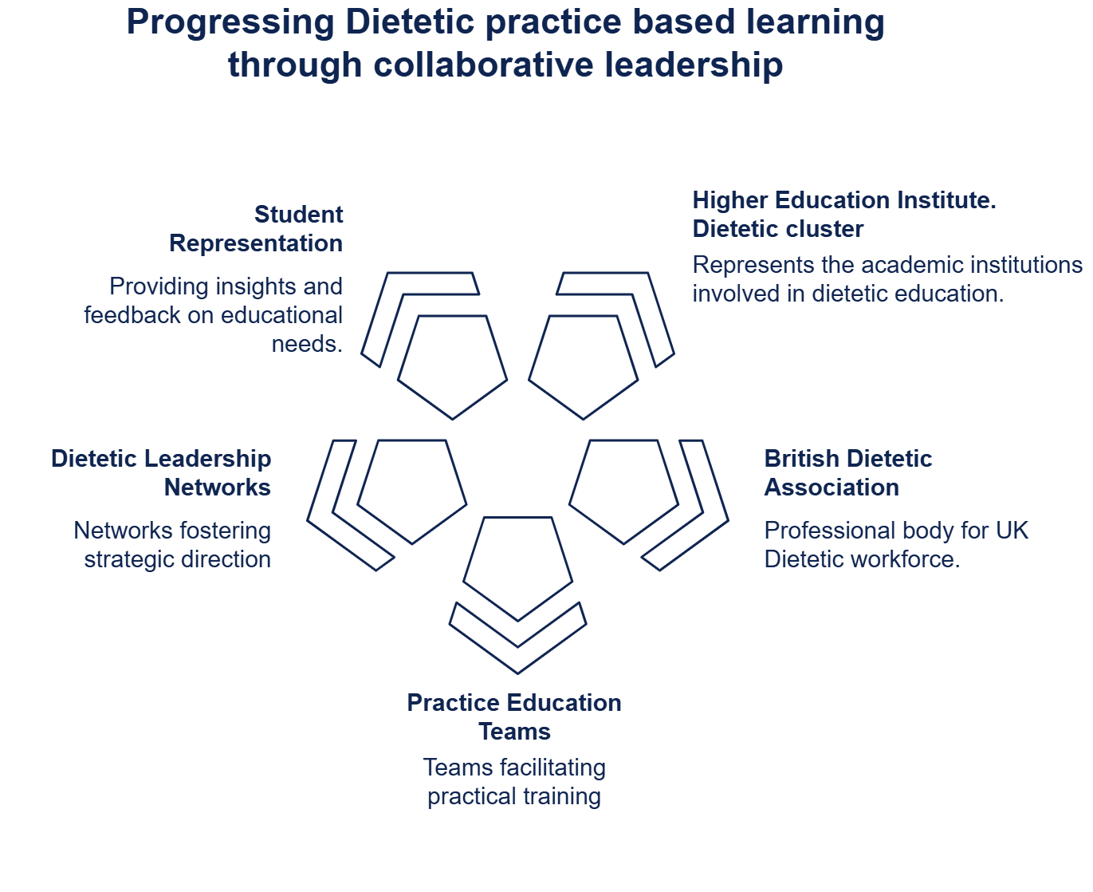

2.0 Task
Scoping
Scoping, illustrated by figure 2, involved literature reviews, data analysis and appreciative inquiry. Quality improvement tools, such as a fishbone diagram, were used to theme and report findings.

Figure 2 Scoping focus
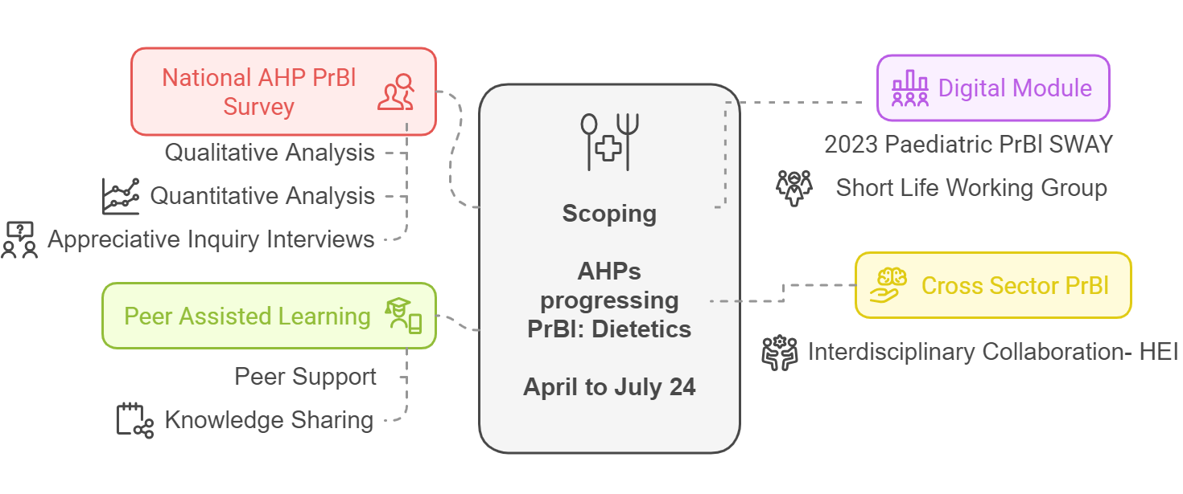
Key findings
Scoping identified the need to build high-quality diverse PrBL opportunities for future Dietitians. A project charter, co-created with stakeholders, identified objectives and goals.

Objectives
- Supporting educational needs for PrBL models, including digital and PAL.
- Scoping approaches for cross-sector PrBL experiences.
- Ensuring equitable PrBL provision for specialist areas.
- Sustaining communication across higher education institutes (HEIs), NHS boards, and other sectors.

Goals: By March 2025
- Implement a digital module for paediatrics, co-produced by an expert group.
- 10% of Dietetic workforce to attend a bitesize education session on PrBL models.
- Implement a test of change PAL ‘champion’ model within one health board.
- Explore requirements for a national forum to support PrBL.
- Develop a resource, sharing cross-sector PrBL models.

3.0 Actions/Outputs
The digital module for specialist areas, Paediatric Dietetics was co-produced, tested and launched in February 25. The Scottish Paediatric leads group will support annual review of the resource.
The growth of the virtual community's membership evidenced collaboration and communication. Dietetic membership increased by 318% from April 24 to March 25. Approximately 10% of the Dietetic profession in Scotland are members, with representation from 14 territorial boards. Polls within the Dietetic forum for Practice-Based Learning indicated a positive shift to recommend the community (Appendix 2).

Educational needs of the profession were met, with 10% attending bitesize training on PrBL. This was defined as attendance at PrBL virtual community spotlight sessions held between April 2024 to March 2025. The development of a cross-sector long arm supervision PrBL podcast was showcased at the national forum, with a dietetic case study in episode 3. The BDA campaign on PrBL utilised the September 2024 Dietetics Today article written by Joanna Teece (Appendix 1).

4.0 Impact
Engagement
- National PrBL Survey- 15% response from Dietetics. 9, 1:1 follow up interviews.
- 10% of the Dietetic workforce in Scotland attended education session on models, including the national PAL workshops and the launch of the AHP practice education development framework. The BDA campaign on PrBL utilised the September 2024 Dietetics Today article and the AHP Practice Education Development framework within BDA platforms, forums and social media.
- Stakeholder forum met 5 times. All 14 boards, Dietetic HEI cluster and BDA education committee representatives attended at least one meeting. Representation included 2 national boards (Health Improvement Scotland and NHS Education for Scotland), 3rd Sector organisation (Food Train), and student representative from Glasgow Caledonian University.
Education impact
- Dietitians attending the forum focusing on PAL reported increased knowledge and confidence.
- Final forum evaluation polls are shown within Appendix 2. There were positive shifts in knowledge of PAL and the net promotor score for the virtual community. The value of collaboration was acknowledged and strengths of current and future Dietetic PrBL.
Performance impact
Stakeholder discussion at the February 2025 Dietetic forum highlighted the desire to integrate data and an action plan for sustainability and maintenance of increased collegiate working across HEIs, Board Practice Educators and the BDA (Appendix 2).

5.0 Learning / Recommendations
Next steps with timeline and partners
2023: Phase 1 recommendations | 2024: AHPs progressing PrBl: Actions completed | 25/26: Recommendation for Next steps
 |  | Report publication: Dissemination to key stakeholders via NES AHP Practice education team as appropriate. Share findings in AHP PrBL Virtual Community.
Stakeholder group should be sustained to ensure continued engagement and collaboration via an ongoing programme of work that recommends next steps for the profession. | Stakeholder forum  Supported by NES support. Bi-monthly national meetings, recorded with spotlight sessions on PAL, LAS and Cross sector PrBL | Promote integration of Scottish Dietetic PrBL forum members into existing forums such as the AHP PrBL Virtual Community. Scottish members to engage in BDA UK-wide resources.
Guidance for cross/third sector placement could be built upon and strengthened with student/ practice educator stories. | Cross-sector scoping  Literature review.  HEI Placement A and C examples.  Podcast see Episode 3. Learning across landscapes: student stories from long arm supervision | Long arm supervision: shaping practice-based learning podcast | Consider future funding opportunities in partnership with HEI/ NES/ Practice educators to enable Cross sector PrBL Evaluation  Assess feasibility of scale and spread with Alzheimer Scotland across 8 centres. Continue to gather practice educator / learner stories. Launch and promote Long Arm Supervision podcast.
Peer Assisted Learning, PAL, should be embedded and promoted within the profession so it becomes business as usual | Peer Assisted Learning (PAL)Forum focused on PAL, and partnership training with board PELs, including consideration of interdisciplinary PAL, review of 2010 workbook and PAL talking heads. | PAL talking heads initiative  NES AHP Practice Education Team, and AHP PrBL Models National Working Group (NWG) to launch and promote Dietetic PAL case studies via the AHP PrBL Virtual community and networks as appropriate.  Consider via NWG how to share and evaluate the impact on Dietetic PrBL PAL.
The digital module for specialist areas could be developed further, e.g mental health where recruitment is challenging and PrBL opportunities are inconsistent across the profession | Learning programme  Evidence-based and developed within Turas for equitable access and evaluation. | National Dietetic Paediatric Leads Group to consider PrBL Paeds learning programme evaluation. For example;  Collaborate with national leads for integration and feedback.  Consider use of this resource alongside common assessment tools.  Expand to further areas of Dietetic PrBL.
Placement models and timetables should continue to be evaluated and refreshed to reflect the Dietitian of the future . | National forum discussion  Consideration of PAL, LAS.  Expansion into public health.  Digital innovation. | In collaboration with the AHP Practice Education network, AHP PrBL Models NWG, and the AHP PrBL Virtual Community consider placement opportunities to innovate and diversify placements.  Consider the driver of BDA UK Common Assessment Tool.  Raise awareness and consider implementation of the AHP Practice Educator Development Framework.

Appendix 1
Dietetic Today- September

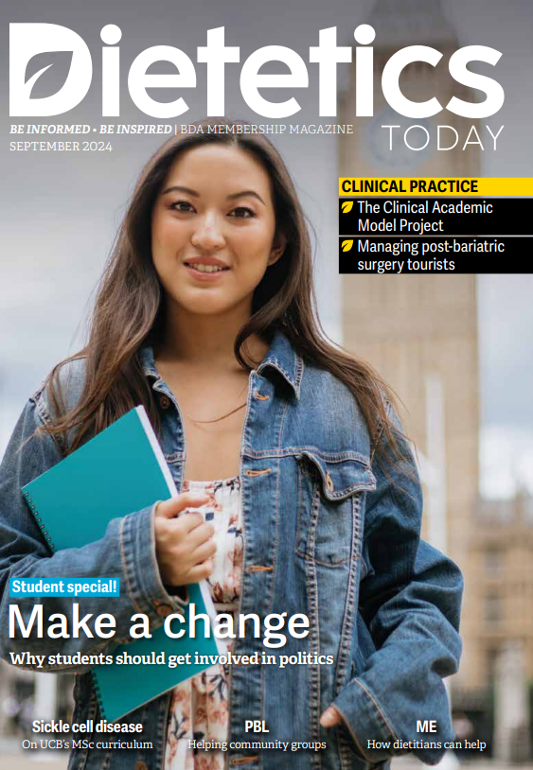

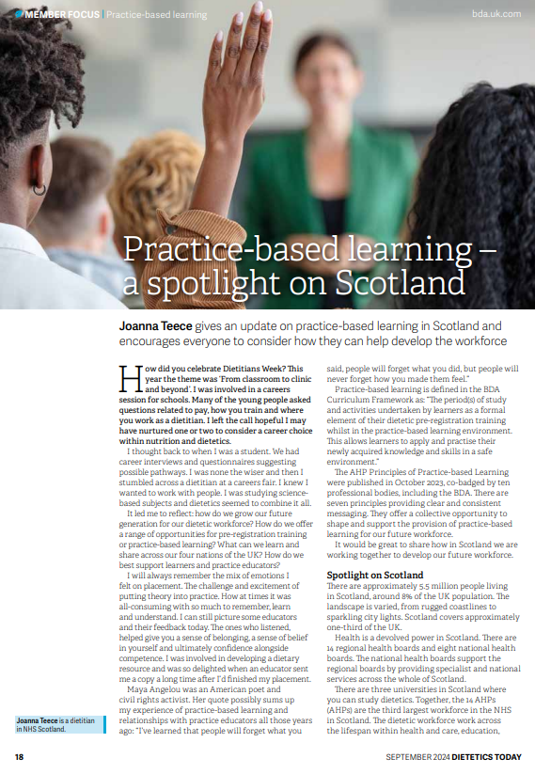

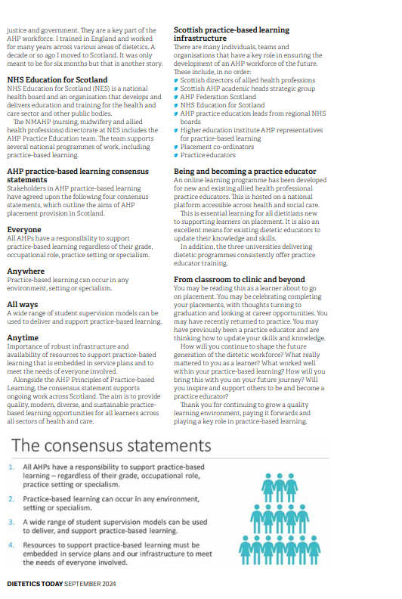

Appendix 2
Dietetic forum evaluation polls – February 2025.

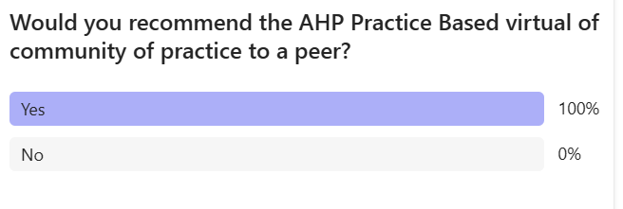

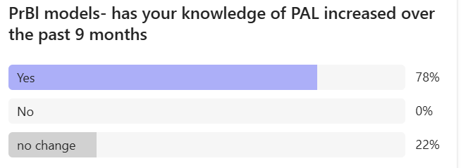

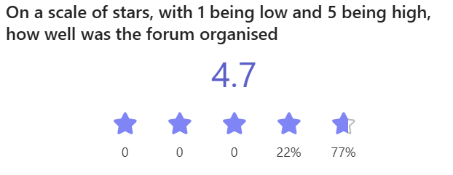

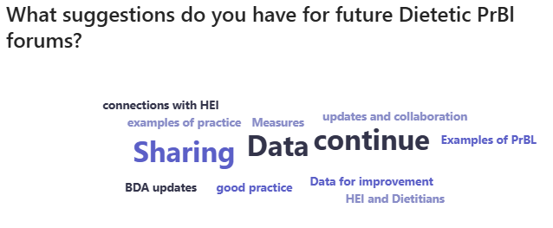

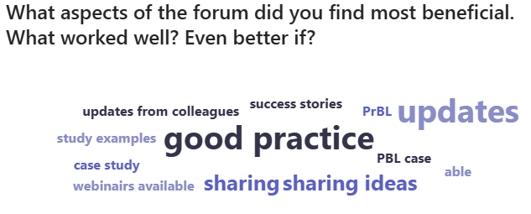

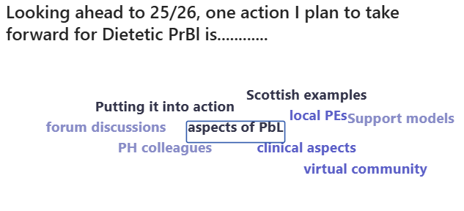


NHS Education for Scotland
Westport 102
West Port
Edinburgh EH3 9DN
tel: 0131 656 3200
www.nes.scot.nhs.uk
© NHS Education for Scotland 2024. You can copy or reproduce the information in this resource for use within NHSScotland and for non-commercial educational purposes. Use of this document for commercial purposes is permitted only with the written permission of NES.

This resource may be made available, in full or summary form, in alternative altformats@nhs.scot to discuss how we can best meet your requirements.

