
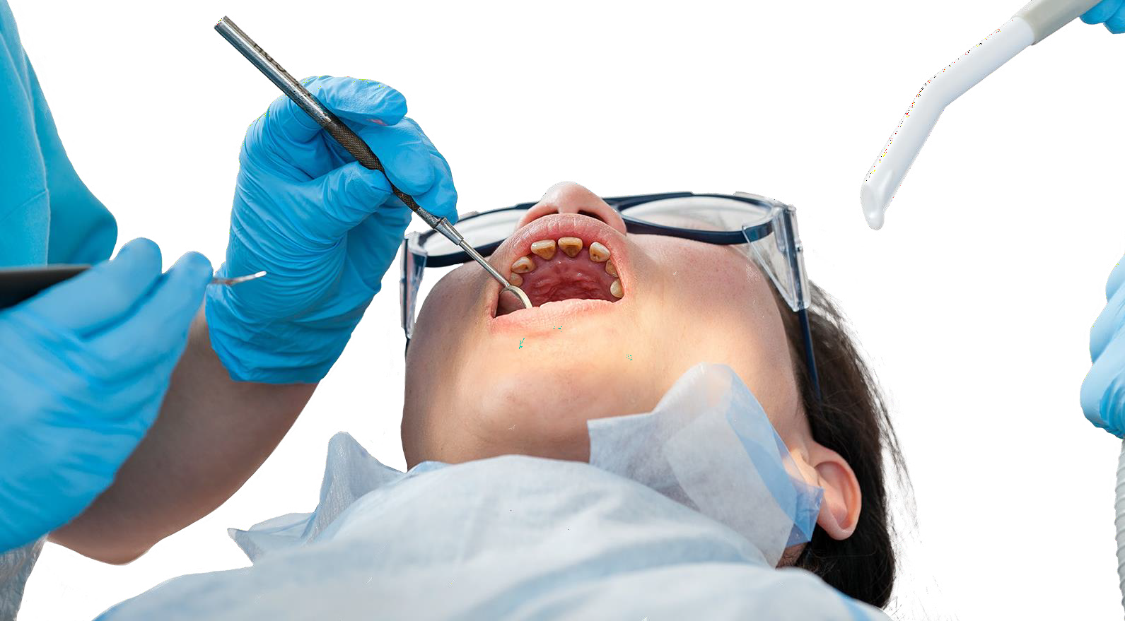
DENTAL VOCATIONAL TRAINING
INFORMATION BOOKLET FOR APPLICANTS
Posts commencing 1st of September 2026





CONTENTS
CONTENTS

SECTION 1
INTRODUCTION
SECTION 2
APPLICATION PROCESS
SECTION 3
TRAINING SCHEMES
SECTION 4
Contact Us

© NHS Education for Scotland 2024. You can copy or reproduce the information in this document for use within NHSScotland and for non‑commercial educational purposes. Use of this document for commercial purposes is permitted only with the written permission of NES.

Dental Vocational Training in Scotland 2


SECTION 1 INTRODUCTION
PAGE 3

SECTION 1

INTRODUCTION
DENTAL VOCATIONAL TRAINING EXPLAINED
THE AIMS AND OBJECTIVES OF DVT
RECRUITMENT PROCESS FOR DVT POSTS
ELIGIBILITY TO UNDERTAKE DVT PROGRAMMES
FURTHER INFORMATION

Dental Vocational Training in Scotland
Dental Vocational Training and Longitudinal Dental Foundation Training in Scotland

3

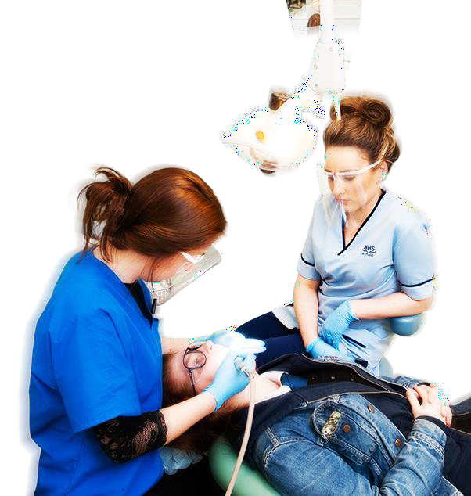
SECTION 1 INTRODUCTION
PAGE 4

DENTAL VOCATIONAL TRAINING EXPLAINED

Dental Vocational Training (DVT)
General Dental Practice is a discipline which requires a particular set of skills and knowledge. Dental Vocational Training has emerged as the established means of developing these skills in new dental graduates. The accepted model of DVT comprises 12 months of supervised clinical experience in an approved training practice, supplemented by an educational programme, which includes weekly tutorials and study days. Travel expenses may be claimable for some VT study days and activities.

Since October 1993, it has been a requirement to complete DVT in order to gain a VT number. In Scotland, since 2004, ‘Satisfactory Completion’ of DVT confers eligibility for a VT number and, in turn, an NHS list number, which allows someone to become an associate or a principal in NHS or a Salaried GDP in the Public Dental Service (PDS).

Dental Vocational Training in Scotland

4

Aim of Dental Vocational Training
PAGE 5
SECTION 1 INTRODUCTION
THE AIMS AND OBJECTIVES OF DVT
Dental Vocational Training (DVT) aims to provide recently qualified dental graduates with the skills necessary to undertake unsupervised General Dental Practice by enhancing clinical and administrative competence, and by promoting high ethical standards and quality of care for patients.

This is achieved by:
- The VDP undergoing supervised training in General Dental Practice Using a planned programme of teaching and assessment to identify
•
and build upon strengths and weaknesses
•
Removing the financial pressures from the training environment so that the VDP can develop free from these
- Continuing the development of professional skills and encouraging postgraduate education

Objective of Dental Vocational Training
The objective of DVT is that by the end of the training period, the VDP is able to practice without supervision and eligible to become an associate/ principal.

The VDP must by the end of the training period, be able to demonstrate competence, relevant to the work of an associate/principal, in the following areas:
- Clinical skills, knowledge and values
- Communication skills and professionalism
- Organisation and management ability
- Management of psychological aspects of patient care
- Teamwork within the practice
- Ability to make decisions in a competent and professional manner,
whilst taking into account personal strengths and weaknesses, and
knowing when it is appropriate to refer
- Knowledge of and adherence to ethical and confidentiality guidelines within General Dental Practice
- Implementation of guidelines and regulations, so as to deliver safe practice
- Utilisation of various resources and support networks available to General Dental Practitioners

PAGE 6
SECTION 1 INTRODUCTION
RECRUITMENT PROCESS FOR DVT POSTS

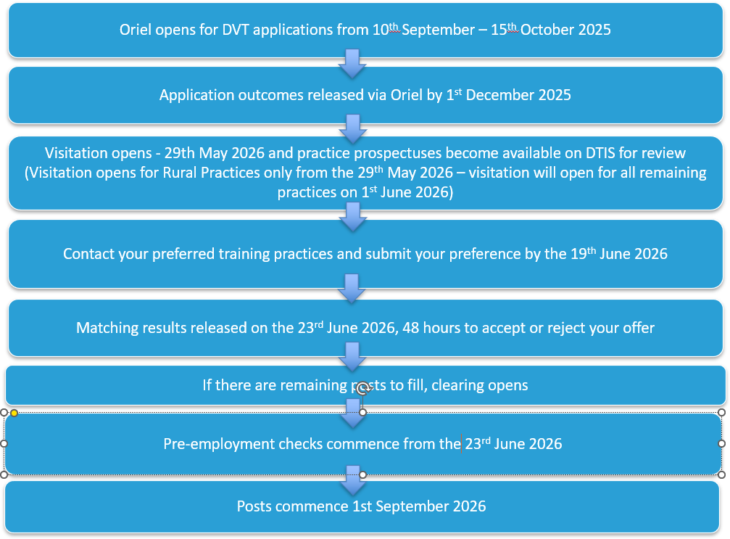

In order to undertake a funded place in Dental Vocational Training (DVT) in the United Kingdom you must meet the following eligibility criteria:
PAGE 7
SECTION 1 INTRODUCTION
ELIGIBILITY TO UNDERTAKE DVT PROGRAMMES
•
Hold a BDS or equivalent by start of the training programme
•
Provide evidence of the right to work in the UK without restriction Have full GDC registration by the start of the training programme. Training is limited to within 2 years of first GDC registration
•

For a full list of the criteria required, please refer to the Dental Vocational Trainee Person Specification available at:

www.nes.scot.nhs.uk/education-and-training/by- discipline/dentistry/dentists/dental-vocational- (foundation)-training/trainee.aspx
If you have any questions about your qualification and whether it is fully recognised by the GDC, or if you would like to find out if you are eligible for full registration, you should visit the GDC website at:

www.gdc-uk.org

Additional Eligibility Criteria
Applicants for whom Dental Vocational Training (DVT) is the only route available to be admitted to a relevant NHS Dental Performers List are given priority in the recruitment process. This applies to candidates who will graduate from a UK Dental School, or to candidates who will graduate from overseas Dental Schools, i.e. from outwith the EEA, for whom DVT is the only route available to be admitted onto a relevant NHS Dental Performers List.

Recruitment Process
Applications will be sorted into two batches. Batch one applicants is for those applicants for whom DVT is the only route available to be admitted to a relevant NHS Dental Performers List, e.g. those graduating from a UK or Overseas Dental School. Batch two applicants is those who have alternative routes for entry onto a relevant NHS Dental Performers List, e.g. those graduating from within the EEA. All offers of posts will be made to Batch one applicants in the first instance. Batch two applicants will be put on hold at the point of application and will only be offered posts should there be remaining posts to fill and no suitable Batch 1 candidates.

Overseas Dentists
PAGE 8
SECTION 1 INTRODUCTION
FURTHER INFORMATION
The Dental Recruitment team will be checking immigration status, eligibility to work in the UK, as well as confirmation of identity.

Please note, should we receive notification of any new legislation set down by the UKVI/Home Office which may impact on any of our applicants, between recruitment opening and offers being issued we will communicate this on our website:

Identity Checks
Applicants are required to submit proof of identity and immigration status at the point of application. This includes those who are UK citizens. You have the facility to scan and upload documents via Oriel at the point of completing your online application.

Information is requested on immigration status to ensure that all applicants are eligible to work in the UK prior to commencement of the training programme. This information will not be used in the selection process, it will be retained separately by the Dental Recruitment team and will be referred to only during longlisting and pre-employment checks.
www.nes.scot.nhs.uk/education-and-training/
by-discipline/dentistry/dentists/dental-vocational- (foundation)-training/trainee.aspx

Sources of Further Information
Please see our website for further information. Our website is updated with important announcements during live recruitment.


SECTION 2 APPLICATION PROCESS
PAGE 9

Dental Vocational Training in Scotland

SECTION 2 APPLICATION PROCESS

ORIEL - HOW TO APPLY
VISITATION PERIOD
PRACTICE PROSPECTUS
THE MATCHING PROCESS
CLEARING AND FAILURE TO PASS FINALS
APPOINTMENTS TO TRAINING POSTS
THE ROLE OF THE VDP
TRAVEL AND SUBSISTENCE

9

Completing Your Application
SECTION 2 APPLICATION PROCESS
ORIEL - HOW TO APPLY
For ALL applications

1 SUBMIT APPLICATION

Log onto Oriel https://www.oriel.nhs.uk/Web/ and
PAGE 11
complete an application by the closing date.

NO APPLICATIONS CAN BE ACCEPTED AFTER THE DEADLINE!
Please refer to the timetable on our website for specific dates: Dental vocational (foundation) training | NHS Education for Scot
Don’t forget to read the NES Applicant Guide before submitting your application!

Please ensure you provide a valid email address when completing the application form.
You should not use your university email address as your main point of contact for this application.
Should you successfully match to a training place, NES will continue to contact you using this email address to complete pre-employment checks and for other employment activities, beyond July 2026.
All information regarding the recruitment process will be sent to this address.
During the recruitment process you may find it useful to periodically check spam/junk folders to ensure that important messages are not missed.

References
SECTION 2 APPLICATION PROCESS
ORIEL - HOW TO APPLY
DVT applicants are not required to submit references within their Oriel application, however may be asked to provide Trainers with a reference during the visitation period and we would advise that you obtain 2 references in advance of the visitation period.

The structured reference form can be downloaded from our website at:
When contacting your referees please ensure that:
You do not use family members as referees
•
- Referees must be able to comment on your clinical ability as a student
- Referees know you sufficiently well to be able to complete the
reference on your behalf

- You give the referees as much advance warning as possible. Remember, if your referee is a clinician at the Dental School, he/
www.nes.scot.nhs.uk/education-and-training/
by-discipline/dentistry/dentists/dental-vocational-
(foundation)-training/trainee.aspx
she may be a referee for a number of people.

PAGE 12

If you are experiencing any issues prior to the application deadline, please contact the Dental Recruitment Team by going to the Service Desk, accessible via the following link https://nesdigital.atlassian.net/servicedesk/customer/portal/30/group/121/create/591 and submitting a support request.

In Scotland, applicants have the opportunity to visit prospective trainers at their practices or communicate through online platforms during a defined visitation period.
SECTION 2 APPLICATION PROCESS
VISITATION PERIOD

More details on the visitation period window are availableon our timetable which can be found on our website:
www.nes.scot.nhs.uk/education-and-training/
by-discipline/dentistry/dentists/dental-vocational-
(foundation)-training/trainee.aspx

Over the course of the visitation period you will be able to visit a number of practices and make arrangements to have a number of interviews. It is a good idea to make a note about each practice following interview to act as a memory aid when it comes to ranking your chosen 7 Trainers on your preference form.
Candidates should ensure that they allow themselves plenty of time to travel to and from the training practices. The responsibilities for all travel arrangements are with the candidate and we advise that you plan carefully.
Please note travel expenses will not be reimbursed.
Before going to interview, it is a good idea to think about what you want from your training programme and about the type of environment in which you will perform best. To help you do this, try reading this information booklet again. Also re‑read the Trainers’ practice profiles, as this might help you focus on areas of interest and questions you could ask when you meet the Trainers. These may include asking about any special interests and typical cases seen in the practice. At the end of the visits and interviews, you will have the opportunity to preference up to seven practices.

PAGE 13
The VT training period is an important time in your career. You should try to ask questions, which will help you to decide whether it is the right practice for you!

At the beginning of the visitation period, and throughout, you will gain access to the Practice Prospectus area of NES Dental Trainer Information System (DTIS). This is an interactive platform where you can view the Trainers profiles. Information on how to access this will be sent prior to visitation from the Dental Recruitment Team.
PAGE 14
SECTION 2 APPLICATION PROCESS
PRACTICE PROSPECTUS

DTIS is an easy to use interactive system that allows applicants to engage with Trainers during the visitation period. It is accessed via a link that will be provided to applicants along with the visitation guidance.

The Practice Prospectus area is your primary tool when planning your visitation period. It has detailed information on the training practices, how many posts are on offer, the type of work that the practice carries out, special interests of the practice and how you should make contact with trainers.

From the information in the Practice Prospectus, you should then decide which practices you are interested in visiting. Trainers will have different preferences in terms of how you make contact with them and submit your CV. You should check each practice profile for information on how to contact individual Trainers.
In order to prepare for the visitation period, you should ensure your CV is up to date and contains all the relevant details to help trainers during interviews. There is no standard format for the CV, but you should take time to prepare it and put in as much relevant information as you can in order to separate you from the crowd. Your CV will be the first impression a Trainer has of you and it will act as a memory aid after interview.
The matching process is very competitive and you should take some time to think about how to set yourself apart from other applicants.

Your CV may include:
- Personal details – name, address, contact details (email, mobile)
- Education – include dental school, any relevant training courses that
you have attended
- Qualifications
- Skills – give evidence of transferable skills you have acquired such as
time management, organisational and communication skills etc.
- Interests – activities where you have leadership or responsibility, or which involve you in relating to others in a team will be of particular
interest. It may also be useful to mention any specific areas of dentistry you are keen to explore in your career
- Additional information, e.g. awards, travel

At the end of the visitation period both Trainers and Trainee applicants complete a preference form listing up to 7 preferences.
PAGE 15
SECTION 2 APPLICATION PROCESS
THE MATCHING PROCESS

At this stage you are required to reflect on what you liked and did not like within the training practices you visited. You may preference up to seven, but you must be prepared to work with each Trainer you put on your list.

We would encourage you to really consider which locations and practices suit your needs so that you can make informed choices during visitation. If you limit your choices (e.g. geographically, listing only one Trainer, staying in city centres etc.) you may not be matched. This is a highly competitive process and you should take some time to think about your options.

Preference Lists
Preference lists are to be completed within Oriel.

The deadline for completing your preference list for VT posts can be found on the DVT timetable on our website.
Trainers will also complete a preference list. Information from the preference list is retained within a database, which will then indicate the number of 1:1 rankings and these places will be allocated. Then, the system identifies the number of 1:2 places – please note the process is led by the Trainer’s top choices, thus in the event of a tie, the Trainer preference is used. This process continues until all the places are allocated.

Matching results will be published to DVT applicants via Oriel. Please refer to the timetable on our website for further details:
You must be prepared to work with anyone you put on your list. You should try not to restrict your choices but you must be sure that you would be happy to work with any of the Trainers that you preference.

We ask however, that you do not preference any practice where your trainer would be a close family member. Further guidance on preference lists can be found within the DVT Applicant Guide on our website.

www.nes.scot.nhs.uk/education-and-training/
by-discipline/dentistry/dentists/dental-vocational- (foundation)-training/trainee.aspx

Clearing
SECTION 2 APPLICATION PROCESS
CLEARING AND FAILURE TO PASS FINALS
If you are not matched with a Trainer at the end of visitation, you will enter the clearing process, as long as there are posts remaining. You will need to view the NES Dental Trainer Information System, where you can access a list of remaining training practices. You may contact the practices directly for further information about available posts and to discuss interview arrangements.

As the clearing stage progresses and appointments are made, the details of training practices will be removed from the Practice Prospectus so that you will know which practices are still available.

The Dental Recruitment Team will provide further information about clearing to unmatched applicants at that time.

Failure to Pass Finals
All DVT posts are dependent upon having full GDC registration, which in turn, is dependent upon successfully passing your final examinations. Unfortunately, some students do fail these exams and, as a result, have to re‑sit later in the year – this means you will not be able to commence your training post.

If you have been appointed to a training post, but have failed your final examinations, you must contact your trainer and contact the Dental Recruitment team by going to the Service Desk here and submitting a support request.

PAGE 16

The majority of matches in Scottish Dental Vocational Training are made as a result of Direct Appointment or via Preferencing. A minority of applicants and Trainers will remain unmatched when results are released on Tuesday 23rd June 2026 @ 10am.
All remaining Trainers and applicants will be put into the clearing process, and a second period of visitation will begin; during this period both parties can agree to an immediate direct appointment.
Clearing will open at or before 5pm on Thursday 25th June 2026, and all those involved will be notified of their inclusion and it opening accordingly.
Should it be found that any Trainers or applicants have made contact, however informally, before the clearing process opens, they will be removed from the 2026-27 Vocational Training Process.

Once offers are accepted and confirmed on the system, successfully matched trainee applicants will undertake pre‑employment checks, listing and registration, requiring regular contact with NES, your Trainer
PAGE 17
SECTION 2 APPLICATION PROCESS
1 2 3
APPOINTMENTS TO TRAINING POSTS
& Trainer’s Health Board and the General Dental Council.
Pre-employment checks for each party:
NES HR - pre-employment checks, payroll and contractual paperwork
Trainer - specific placement details e.g. base location, working hours
Trainer’s Health Board - listing process GDC - professional registration
All those appointed MUST ensure they liaise directly with NES and their Health Boards and provide ALL necessary documentation, as well as return ALL Start Pack documentation as soon as possible.
Failure to do so may result in trainees not being able to take up post on the specified start date, which will have an impact on the training practice or hospital unit, or on salaries to be paid on time.
- NES
Important: NHS Education for Scotland (NES) is the employer of Vocational Dental Practitioners joining Dental Vocational training in NHS Scotland.

Once you match to a training place, the process is as follows:

  - You will first receive a pre-employment check poster, offering a quick overview of the requirements for successfully completing pre-employment checks.
  - Following that, you will receive a welcome email from Turas, granting you access to the Turas People platform.
  - Subsequently, you will receive a pre-employment letter (via email) from NES. This letter will contain instructions on how to complete pre-employment checks and provide details about the necessary payroll paperwork.
  - Additionally, all trainees will be issued a conditional offer of employment from NES.
You will be asked to complete and submit:

Staff Engagement Form: You must complete and submit the Staff Engagement Form at least four weeks in advance of your start date to enable you to be added to payroll.
Occupational Health Check: You must complete and submit the Health Declaration Questionnaire and confirm your immunisation status on Turas People.
PVG: Protection of Vulnerable Groups Scheme: There is a requirement to instigate a PVG check with the Disclosure Scotland Office and any conviction records to be disclosed. NES will carry out an ID check prior to sending you a PVG Application online.

GDC membership: you must present the current GDC practicing certificate.
PAGE 18
SECTION 2 APPLICATION PROCESS
1 2 3
APPOINTMENTS TO TRAINING POSTS
•
Qualifications: You must provide a copy of your BDS degree (Bachelor of Dental Surgery) or equivalent.
•
Identity and immigration documents: NES sponsors all Medical and Dental Trainees in Scotland who require Skilled Worker sponsorship. The sponsorship team will contact you with relevant instructions, if applicable.
•
Fitness to Practice: You must complete a Fitness to Practice declaration form available on Turas People.
•

Once pre‑employment checks are satisfied, including having received your exam results, Health Board list number, GDC registration and evidence of right to work in the UK, you will be issued with a copy of your contract, via Turas People.

You will also attend your regional Postgraduate Centre at the start of your training for induction, where you will receive further details of your training programme. The DVT administration teams will contact you to send you information about your induction using the email address you provided on your application form. Please note, this may not be a face‑to‑face induction.

Trainer
You should contact your Trainer to discuss specific details regarding your training with them, including details of:
- base location
- working hours
- local working
- practices and induction arrangements.
- Trainer’s list number*
*More information in the next slide
Important: Your passport and any right to work documents will be checked on your first day in the practice. If they have not been attested prior to day 1, they will also need to be attested and submitted to NES HR.

Trainer’s Health Board - listing process
It is a requirement of the appointed trainee to liaise with the Health Board about Health Board information and Medico‑Legal Indemnity. Documents will vary amongst the Health Boards with regards to relevant health aspects, and it will be your responsibility to ensure you follow this up with the Health Board prior to taking up post.

Health Board requirements may include:
  - Copy of passport and/or birth certificate

  - Evidence of Hepatitis B status and other health clearances
PAGE 19
SECTION 2 APPLICATION PROCESS
1 2 3
APPOINTMENTS TO TRAINING POSTS
  - Copy of GDC current practising certificate
  - Copy of membership of Medico‑Legal Defence Organisation
  - PVG (Protecting Vulnerable Groups)
  - Satisfactory references
Rehabilitation of Offenders
Under the terms of the Rehabilitation of Offenders Act 1974, you are required to disclose CRIMINAL convictions, which are unspent (current). The National Health Service employment for which you are applying is EXCLUDED in the provisions of the Act. You are required NOT to withhold information about convictions which for
other purposes are “spent” under the provisions of the Act. This means that all previous convictions must be declared. If you are offered employment, any failure to disclose such convictions could result in dismissal or disciplinary action. Any information given, however, will be completely confidential and will be considered only in relation to the post for which this application form refers. You must also disclose any pending proceedings and cautions.

List Number: You are required to hold a secondary list number of the Trainer, issued by the Health Board area for the practice where you will complete training. Please ensure that you provide all the necessary information to the Health Board so this process is complete in a timely manner. The listing process is carried out by the Health Board directly and we will be liaising with the Health Boards on the progress of this.

GDC Registration
Please note that GDC registration normally takes at least six weeks to process, and it is therefore important that you apply at your earliest possible opportunity. This means that you should be in a position to submit your paperwork to the GDC, fully completed and carefully checked, on the day you receive notification of success in final exams.

Any delays in applying for your GDC registration may prevent you taking up post or may delay the date upon which you can start work and could affect your pay at the end of September and impact on the Dental Practice. It could also affect your ability to comply with the requirement to complete one year in practice by the end of August 2026.

If your certificate is in a language other than English you must check with GDC whether or not your certificate needs to be translated into English.

SECTION 2 APPLICATION PROCESS
PAGE 20
THE ROLE OF THE VDP

The Role of the VDP
Once you start as a VDP within DVT, you will become an assistant for one year to your DVT Trainer within the training practice from the 1st September 2026. Information on Trainer and VDP obligations is available and can be found within the standard Single Employer contract. NES will provide you with a copy of this document.
Vocational Dental Practitioners will be required to:
Enter into and abide by the terms of a legal contract for full‑time employment with NES.
•
- Attend the day or block release courses as set out in the published programme. Absence from the study day course for any reason would
be authorised only in exceptional circumstances. VDP’s must notify their Associate Dean or VT Adviser of any absence in advance and in writing. All missed days must be made up in your own time.
- Take holidays outwith the educational programme. Unexplained
absence from the course will imply withdrawal from the scheme by
both VDP and Trainer.
- Complete such educational studies and assessment as may be required.
- Inform the Associate Dean or VT Adviser of any alteration in the circumstances of the practice, the Trainer or self which might alter the
contract of employment as a VDP.

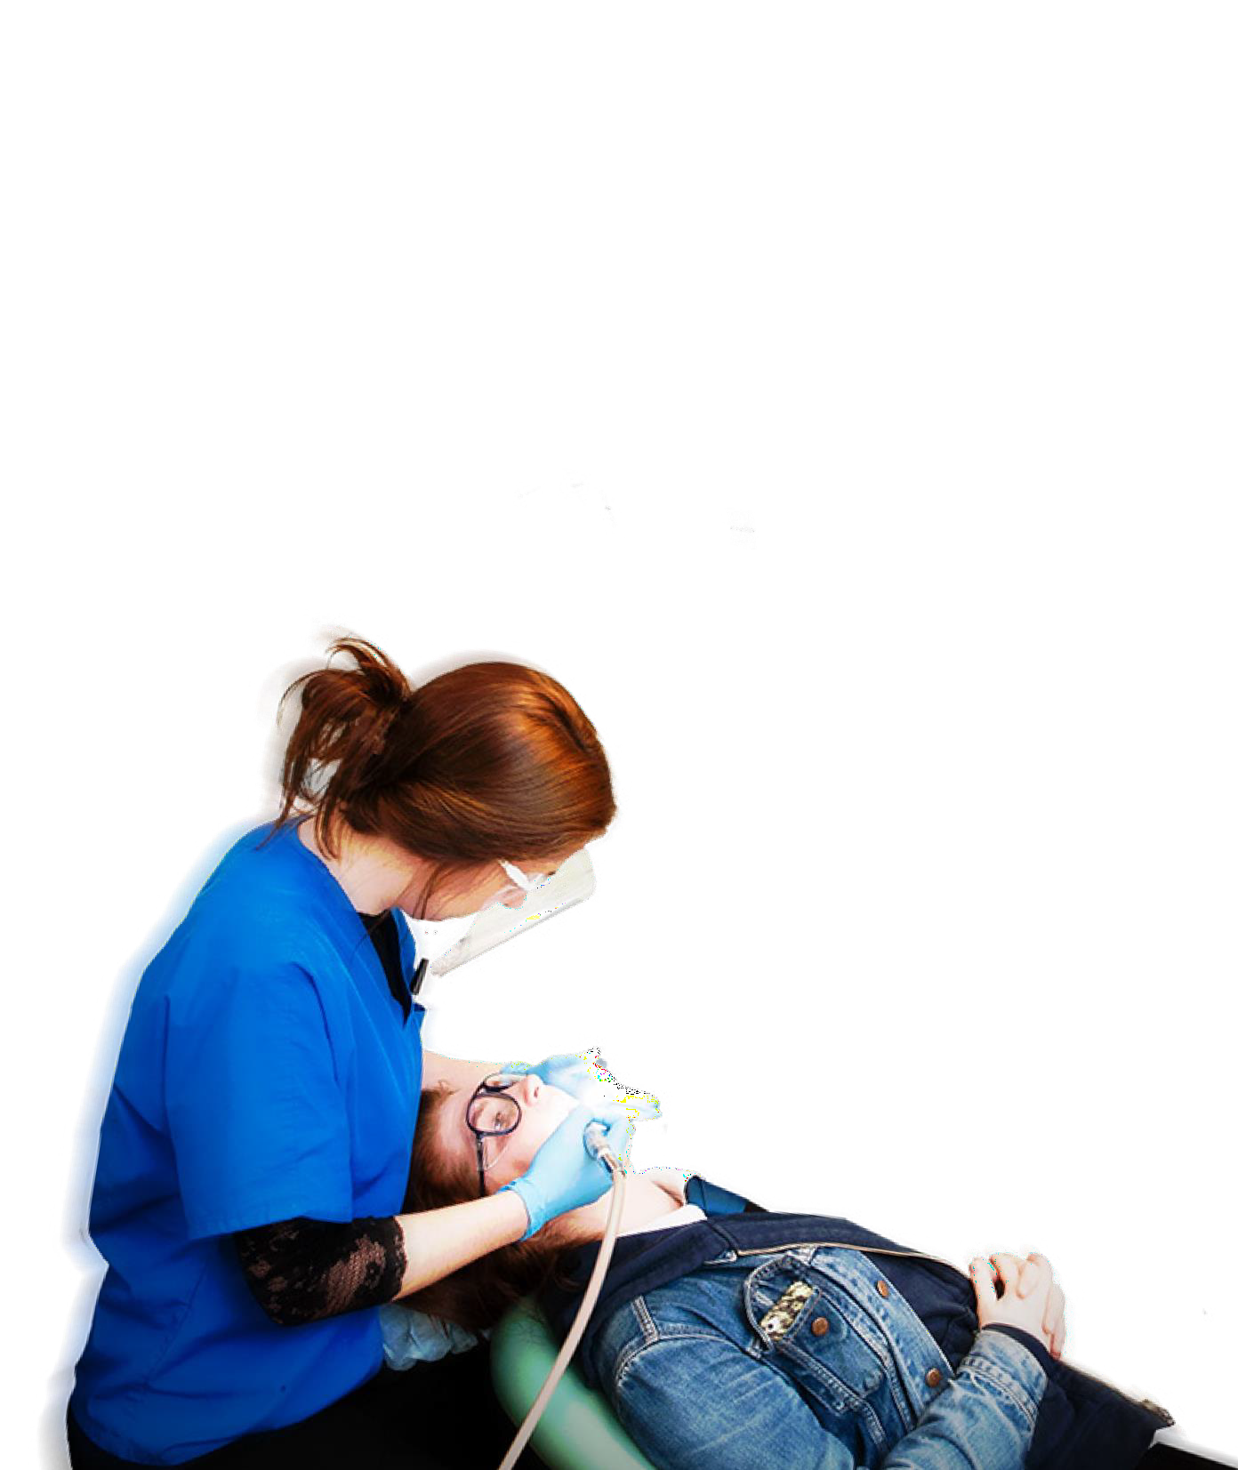

Dental Vocational Training in Scotland 19

SECTION 2 APPLICATION PROCESS
PAGE 21
TRAVEL AND SUBSISTENCE

Travel and Subsistence for Study Days
Travel and subsistence payments for attendance at study days may be claimable, depending upon the location of the Postgraduate Centre in relation to the practice and the place of residence.
This will be confirmed by the relevant Postgraduate Centre Office upon commencement of training and any payments made will be in line with the NHS Education for Scotland Travel and Subsistence Policy.

For further information of Trainer and VDP obligations, please refer to the standard Trainer/Trainee contract.


Dental Vocational Training in Scotland
20


SECTION 3 TRAINING SCHEMES
PAGE 22

Dental Vocational Training in Scotland
Dental Vocational Training and Longitudinal Dental Foundation Training in Scotland

SECTION 3

TRAINING SCHEMES

TRAINING SCHEMES - INTRODUCTION
TRAINING SCHEMES - NORTH EAST REGION
TRAINING SCHEMES - NORTH REGION
TRAINING SCHEMES - EAST REGION
TRAINING SCHEMES - SOUTH EAST REGION
TRAINING SCHEMES - WEST REGION

21

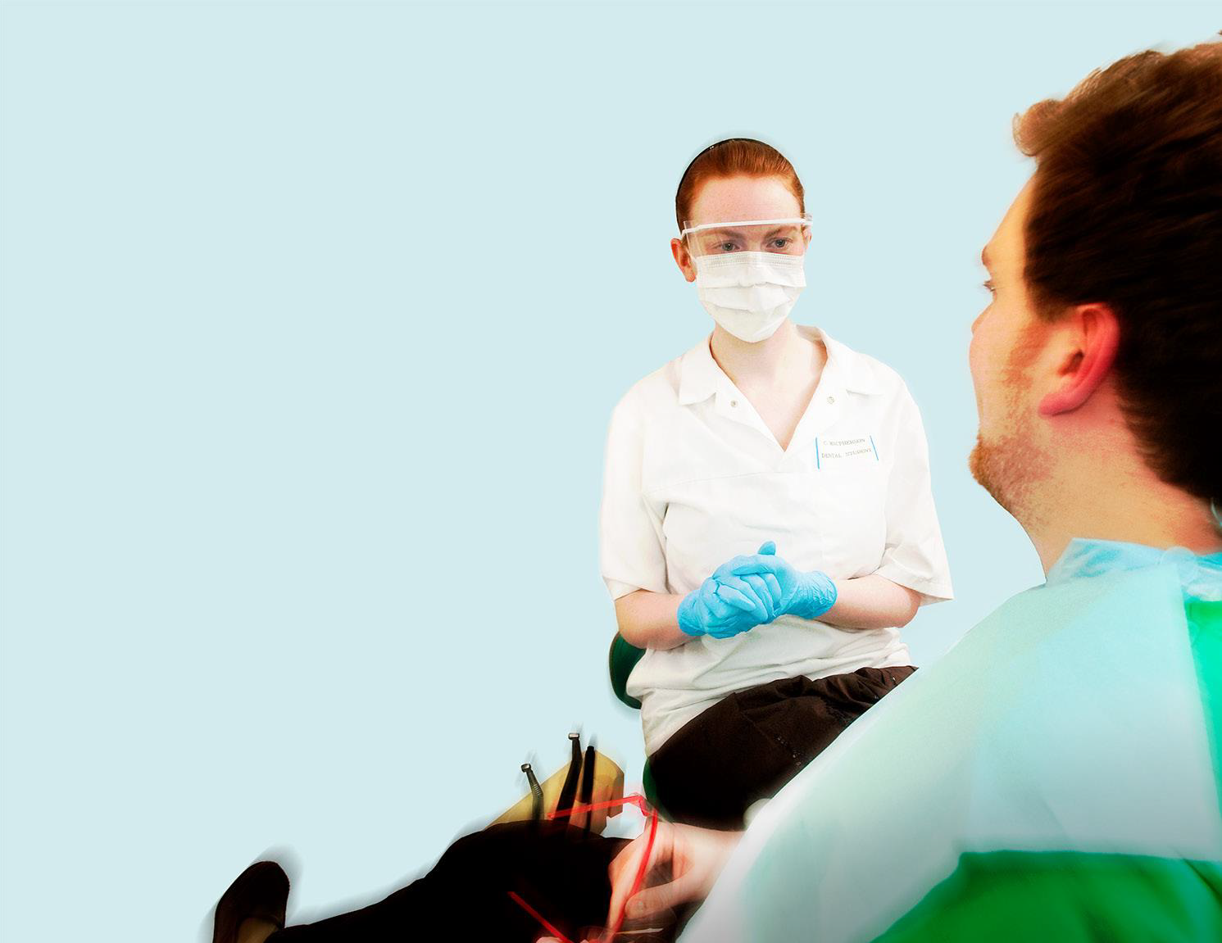
SECTION 3 TRAINING SCHEMES
PAGE 23

TRAINING SCHEMES - INTRODUCTION

Introduction
This section contains information about each of the regions and the schemes they have to offer.

You might want to stay where you studied and where your friends are – but what about trying somewhere new?

We would encourage you to carefully consider which regions best suit your needs so that you can make informed choices during visitation. If you limit your choices (e.g. geographically, listing only one Trainer, staying in city centres etc.) you may not be matched. This is a highly competitive process and you should take some time to think about your options.

Some practices in the regions may be training under the multiple training model, where there is capacity for more than one trainee per Trainer.
We strongly encourage all candidates to take some time to discuss with your significant other, and/or family members, the various options available to you.

Dental Vocational Training in Scotland 22

SECTION 3 TRAINING SCHEMES
PAGE 24

TRAINING SCHEMES - NORTH EAST REGION

Aberdeen DVT Scheme
This is a Dental Vocational Training scheme based in Aberdeen. The study days are held on Fridays at Aberdeen Dental Education Centre (ADEC), Foresterhill, Cornhill Road, Aberdeen.
As well as some online events, ADEC offers excellent study and practical facilities with a training surgery/LDU and clinical skills room with phantom heads and state of the art IT. We regularly train graduates from all corners of the UK.



Aberdeen
The study programme, as with the rest of Scotland, consists of a minimum of 25 study days. Most of these are held at ADEC on Fridays but we also occasionally arrange for trainees to attend conferences, visit laboratories and liaise with other schemes to hold joint days elsewhere as well as some online events. This provides ample opportunity to catch up with your colleagues from the other schemes.
The training practices in this scheme are usually spread over a wide geographical area across the North East. Aberdeen City is very well represented and the other practices have in the past been situated in thriving communities such as Banff, Fraserburgh, Inverurie and Banchory. VDPs based in the North East will find themselves in the unique position of having the countryside almost on their doorstep but never being too far away from city life. The Cairngorm National Park offers ample opportunity to escape into the hills for a multitude of sporting and recreational pastimes. The city of Aberdeen is an ideal place for those looking for art, culture and music with many different venues offering a diverse choice of entertainment. Good air, train, bus and road links mean that you are never too far from any destination!

PAGE 25

Aberdeen Dental School is adjacent to ADEC. Secondary care services in Orthodontics and Restorative, previously based in Aberdeen Royal
SECTION 3 TRAINING SCHEMES
TRAINING SCHEMES - NORTH EAST REGION
Contact Details for the North East Region of Scotland
Andrew Leitch, AssistantPostgraduate DentalDeanVT
Andrew.Leitch@nhs.scot
Amro Alkado, VT Adviser
amro.alkado@nhs.scot

Infirmary, are now operating in the Dental School. We are fortunate to have this resource and make use of the expertise available for study days.

SECTION 3 TRAINING SCHEMES
PAGE 26

TRAINING SCHEMES - NORTH REGION

The North of Scotland has two Dental Vocational Training schemes covering the largest VT area in Scotland. The training practices in this scheme have traditionally been located in a diamond shaped area from Oban in the South to Western Isles in the West, Shetland in the North and Elgin in the East.

The area has an extremely diverse social and cultural history. It includes the highest mountains, the deepest lochs and the most beautiful countryside in Scotland. The sporting opportunities are endless. Inverness is the central hub for air, road and rail transport and is situated approximately three hours from Glasgow or Edinburgh.

Why choose the North?
•
Three‑day block release (eight per year) Including some online events;
- Study blocks held at the Centre for Health Science with ‘state of the art’ facilities;
•
Practices are based in beautiful rural areas of Scotland;
- Trainers have a very high standard of facilities at their practices and clinics;
•
Wide variety of clinical cases;
•
Highly skilled and motivated Trainers; All Trainers are involved in study days;
•
- Lifestyle choice, fantastic outdoor pursuits and social scene.

Oban

Elgin



Because of their geographical location the practices in the Highlands and Islands provide a particularly broad range of treatment. This gives the VDP an opportunity to expand their skill range, giving a very good grounding for life beyond DVT.

PAGE 27

Vocational Training Advisers (VT Advisers)
SECTION 3 TRAINING SCHEMES
TRAINING SCHEMES - NORTH REGION
Contact Details for the North Region of Scotland
Andrew Leitch, Assistant Postgraduate Dental Dean VT  andrew.leitch@nhs.scot
Ed Bateman, VT Adviser edward.bateman1@nhs.scot
Ross Ellison, VT Adviser
ross.ellison@nhs.scot

Mr Ed Bateman holds one of the two VT Adviser posts for Trainers and VDPs and is extremely experienced and very highly respected by GDP’s and VT Advisers.

The North Region Study Day Programme is constantly evolving with the Advisers taking on board feedback from existing and previous year’s VDPs to provide an elite and enjoyable learning experience.

SECTION 3 TRAINING SCHEMES
PAGE 28

TRAINING SCHEMES - EAST REGION

The East Region of Scotland incorporates all of Tayside, the North of Fife down to Kirkcaldy and parts of the Forth Valley area. The region is rich in natural beauty, recreational opportunities and convenient transport links. Being based in the East of Scotland puts dentists in easy reach of a whole range of outdoor and cultural pursuits, whether it be water based, high mountains, music or art. In the East of Scotland we offer DVT on the East 1 and 2 based schemes.

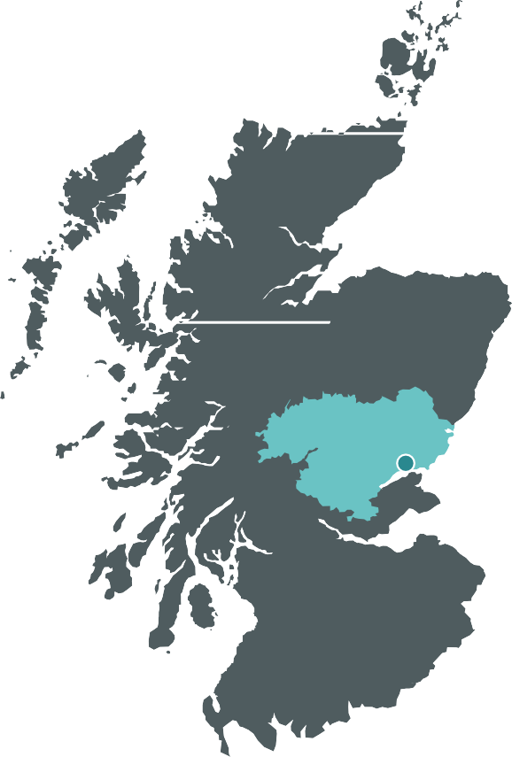

Dundee

East DVT Scheme 1
This scheme is currently based in Dundee with study days in Dundee Dental Education Centre, Frankland Building, Dundee which provides exceptional training and hands on facilities. Tayside has superb recreational opportunities and is convenient to all the main cities.
  - In recent years the DVT practices have been spread between Montrose,
Arbroath and Kirriemuir through Dundee, Invergowrie, Carnoustie and
Blairgowrie to Perth in the west.
  - The study days are held on Thursdays at Dundee Dental Education Centre (DDEC) and are run by Claire Harrison.

East DVT Scheme 2
This scheme is currently based in Dundee with study days in DDEC, Frankland Building, Dundee which provides exceptional training and hands on facilities. Tayside has superb recreational opportunities and is convenient to all the main cities.
  - Some of the practices on East Scheme 2 are in Fife
  - The DVT practices are spread between Dundee, Newport on Tay,
Coupar Angus, Perth and Brechin.
•
The study days are held on Thursday and Fridays at Dundee Dental Education Centre (DDEC and are run by Gordon Fletcher and Claire Harrison.


PAGE 29
SECTION 3 TRAINING SCHEMES
TRAINING SCHEMES - EAST REGION

Contact Details for the East Region of Scotland
Fiona McFadzean, AssistantPostgraduateDentalDeanVT
fiona.mcfadzean@nhs.scot@nhs.scot
Gordon Fletcher, VT Adviser gordon.fletcher@nhs.scot
Claire Harrison, VTAdviser
claire.harrison2@nhs.scot

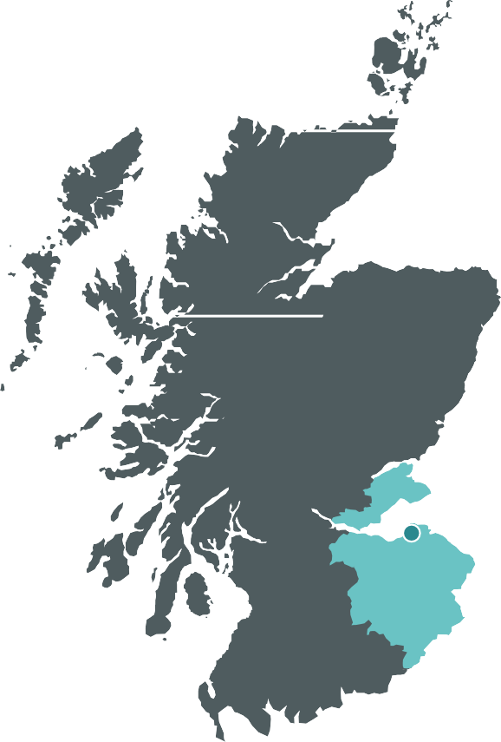
SECTION 3 TRAINING SCHEMES
PAGE 30

TRAINING SCHEMES - SOUTH EAST REGION

South East Scotland consists of three Health Board areas:
Borders, Lothian and Fife. This part of Scotland is an attractive area to commence a dental career with many recreational and educational
opportunities. Edinburgh, where our schemes are based, is a stunning, vibrant international city with many diverse cultural and artistic activities. We usually attract graduates from all over the UK and our schemes are designed to enable you to get to know each other and to benefit from the experience of your colleagues who many have qualified from other universities. This has traditionally been valued by trainees, as has the opportunity to meet new colleagues and friends. Our schemes are based in
the Edinburgh Dental Education Centre, located in the centre of Edinburgh, which is also home to an extensive range of postgraduate dental education and training programmes for all members of the dental team.

We offer three DVT schemes in General Dental Practice for one year from September to August, in common with the rest of Scotland. One scheme has their study day on a Thursday, one on a Friday and the third is a block training scheme. The General Dental Practice Trainers within the DVT schemes, in common with the other schemes in Scotland, have been carefully chosen for their commitment to training and postgraduate education.

Edinburgh





SECTION 3 TRAINING SCHEMES
PAGE 31
TRAINING SCHEMES - SOUTH EAST REGION

Many of the practices involved are not in Edinburgh itself, but often these provide more occasions to treat patients in a more holistic manner. New graduates will be able to experience all aspects of dentistry and management within a caring environment.

Contact Details for the South East Region of Scotland
Fiona McFadzean, AssistantPostgraduateDentalDeanVT fiona.mcfadzean@nhs.scot
Fiona McPhail, VT Adviser fiona.mcphail3@nhs.scot
Christopher Ogle, VT Adviser christopher.ogle@nhs.scot
Michael MacMillan, VT Adviser
michael.macmillan1@nhs.scot

Dental Vocational Training in Scotland
30

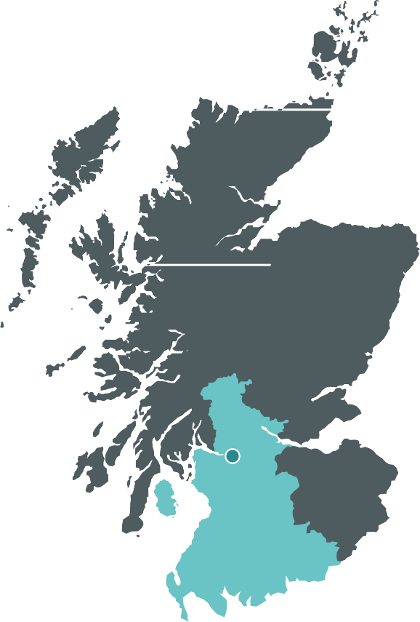
SECTION 3 TRAINING SCHEMES
PAGE 32

TRAINING SCHEMES - WEST REGION

The West of Scotland Region consists of five Health Boards areas; Greater Glasgow & Clyde, Lanarkshire, Forth Valley, Ayrshire & Arran and Dumfries & Galloway. This covers a wide and diverse area, from Argyll plus some of the West coast islands, in the North to the Solway Firth in the South. The region includes tranquil rural and island locations in addition to urban areas like Glasgow, the largest city in Scotland. All aspects of culture, sporting and social activities are catered for in the region. Glasgow has excellent bus, rail and air connections to all parts of the UK and beyond.

Vocational Training study days are based in the Glasgow Dental Education Centre (GDEC) which is situated next door to Glasgow Dental Hospital & School, Sauchiehall Street, in the centre of Glasgow and provides training for all branches of the profession.
Training in the West of Scotland currently consists of seven VT schemes.
7

Each scheme has a separate Adviser and a separate educational programme.
- Six of the schemes are day release format, with the study day
programme mostly being delivered on a particular day of the week.
- The other scheme is based on a block release format, where days are provided in 2/3 day blocks.

Glasgow

Dental Vocational Training in Scotland
31


SECTION 3 TRAINING SCHEMES
PAGE 33
TRAINING SCHEMES - WEST REGION

VT Administration
VThub@nes.scot.nhs.uk
Gavin McLellan, VT Adviser
gavin.mclellan2@nhs.scot
John Hyland, VT Adviser
john.hyland@nhs.scot
Terri Hamilton, VT Adviser
terri.hamilton3@nhs.scot
MartinMcKinstry,VTAdviser
martin.mckinstry@nhs.scot
James McCall, VT Adviser
james.mccall@nhs.scot
Victoria Golding, VT Adviser
victoria.golding@nhs.scot
Andrew MacKinnon, VT Adviser andrew.mackinnon@nhs.scot
Billy Cameron, Assistant Postgraduate Dental Dean VT william.cameron@nhs.scot
Contact Details for the West Region of Scotland

Dental Vocational Training in Scotland 32

SECTION 4 Contact Us
PAGE 34

SECTION 4

Contact Us

CONTACTS FOR DENTAL RECRUITMENT

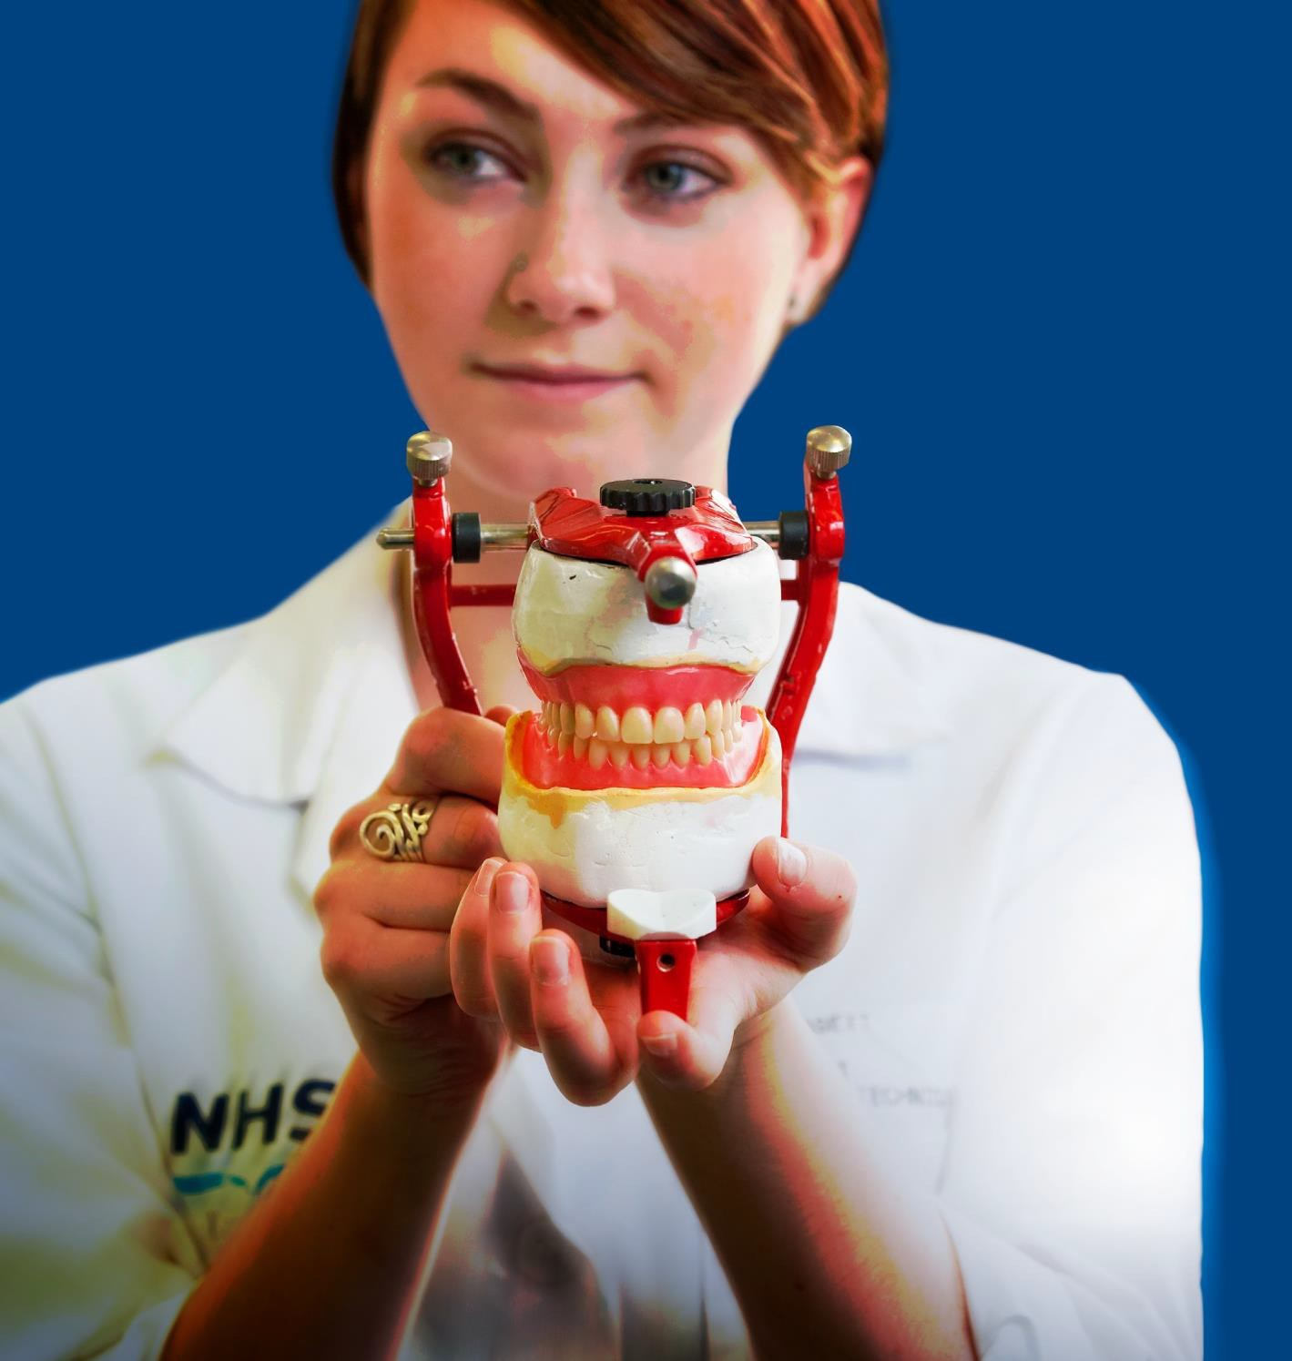
Dental Vocational Training in Scotland
Dental Vocational Training and Longitudinal Dental Foundation Training in Scotland
33

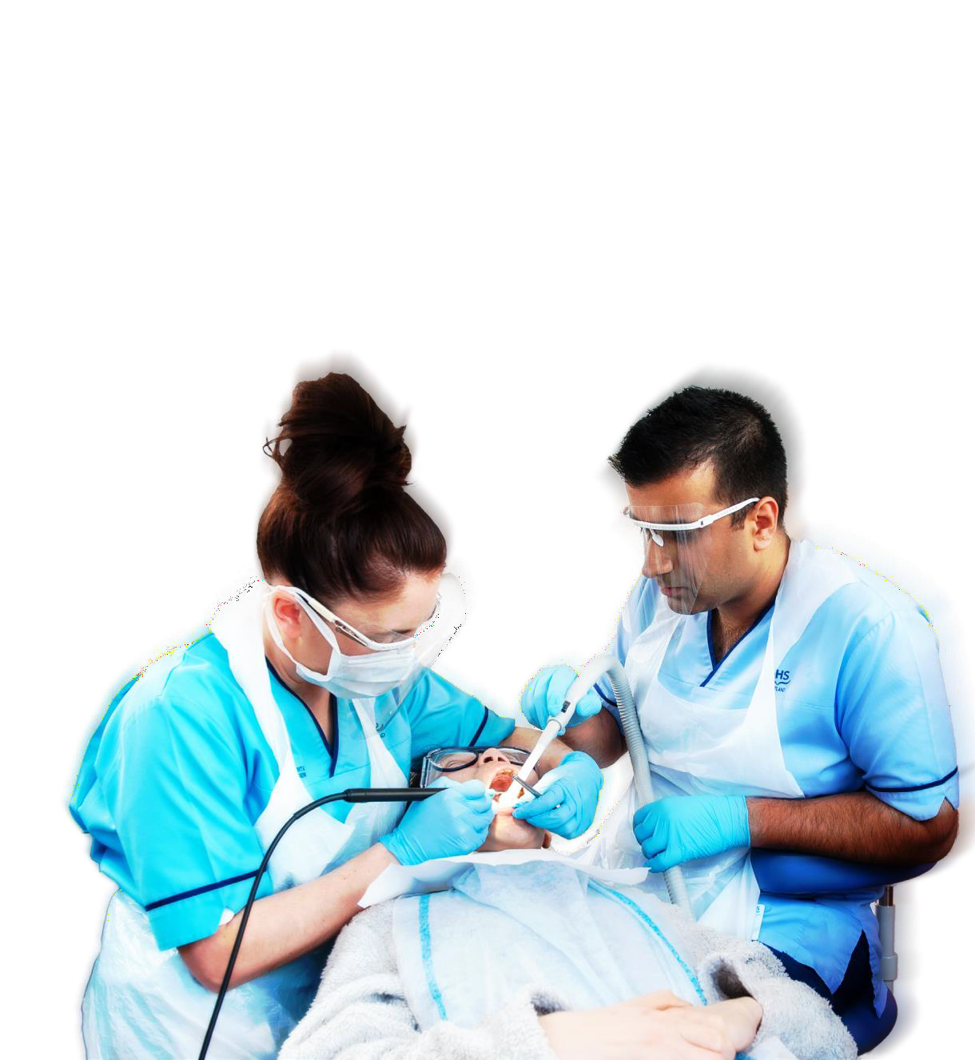
SECTION 4 Contact Us
PAGE 35

CONTACTS FOR DENTAL RECRUITMENT

Dental Recruitment Team
If you have any queries regarding the recruitment process, please contact:
https://nesdigital.atlassian.net/servicedesk/customer/portal/30/group/121/create/591

Finance Team
If you have any queries regarding payroll administration, please contact:
https://nesdigital.atlassian.net/servicedesk/customer/portal/5/group/21

Dental Department

VT Administration
vthub@nes.scot.nhs.uk

34


ALTERNATIVE FORMATS

This resource may be made available, in full or summary form, in alternative formats and community languages. Please contact us on 0131 656 3200 or email altformats@nes.scot.nhs.uk to discuss how we can best meet your requirements.

NHS Education for Scotland Westport 102
West Port Edinburgh EH3 9DN tel: 0131 656 3200
www.nes.scot.nhs.uk

NESD1523 | Designed and typeset by the NES Design Service.

