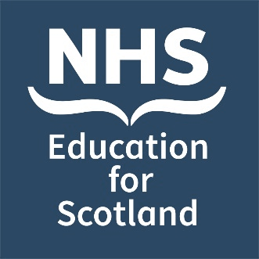
Date: Tuesday 11 November 2026
Bereavement Education Conference
Poster Abstract Submission Form 2026
Venue: Virtual

Invitation: You are invited to submit poster abstracts for the NHS Education for Scotland (NES) bereavement education conference

https://www.nes.scot.nhs.uk/events
#NESBereavement2026

NES is very pleased to be hosting its seventh bereavement education conference on 11 November 2026. This one-day event will be relevant to all health and social care staff.

Submissions are welcome from those working within Scotland and beyond, and from all sectors including health and social care services, integration authorities, voluntary and partner organisations and other public or private sector organisations.

Poster categories: We invite submissions of poster abstracts covering any aspect of innovation and creativity leading to improved outcomes:
- for those who are bereaved and / or
- for staff who experience death and bereavement in the course of their work.

These may include aspects of education, service delivery and quality improvement relevant across a wide spectrum of bereavement related situations. We are also happy to accept work that has already been presented at other events.

Abstract template: Please use the abstract template on the following page to complete your submission and send your completed form to events@nes.scot.nhs.uk. Please also direct any queries or requests for further information to this email address.

Key dates:

Deadline for poster abstract submissions | Monday 7th September at 12 noon BST
Lead authors will be notified whether their abstract has been selected by | Friday 25th September

Poster title
Lead Author details: | Name:
Lead Author details: | Job title:
Lead Author details: | Organisation:
Lead Author details: | Email address (Please provide a work email address where possible):
Affiliation / institution where the work has been carried out:

Details of co-author(s) – please include, name, job title, organisation:

Authors of successful abstract submissions will have their poster published on the NES Support Around Death and Events websites and they may also be posted on our social media channels.  Please select yes / no to confirm whether or not you agree to your poster being published in these ways. |  | Yes ❒
 |  | No ❒

Abstract text (300-word limit) – You may find it useful to utilise the following structure (Introduction, Methods, Results / Discussion, Conclusion) but this is not mandatory.

