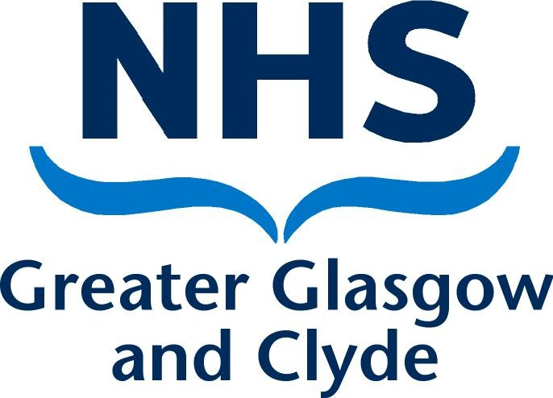

NHS Greater Glasgow and Clyde
JOB DESCRIPTION
SPECIALTY TRAINEE in ORAL SURGERY

Brief Outline:

This is a full-time post in an established training programme with NHS Greater Glasgow and Clyde.

The posts offer the opportunity to undertake a full-time training programme in the specialty of Oral Surgery based on the Curriculum for Specialist Training in Oral Surgery, leading to the award of a CCST. The curriculum for specialty training in oral surgery is available on the General Dental Council website www.gdc.org

The post holder will be expected to:
- participate fully in training
- participate in clinical or other service activities e.g.: meetings, service development
- undertake clinical audit, quality improvement and participate fully in clinical governance activities
- participate in some undergraduate teaching
- will have the option to pursue research or other original work as time allows

The Training Programme:

This programme has been recognised by the Specialist Advisory Committee in Oral Surgery for a four-year training period leading to eligibility to sit the Specialty Fellowship Examination in Oral Surgery. The post has approval from the Postgraduate Dental Dean and Training Number will be awarded to the appointee. All Oral Surgery trainers in Glasgow Dental Hospital are on the specialist list. There is no out of hours or on call commitment. Training will also be provided by consultants in related dental specialties.

The programme will comprise on a weekly basis approximately eight clinical sessions, with the balance being allocated for study, research, audit, quality improvement administration or didactic teaching.
Performance assessments and reviews (ARCP) are carried out at the six-month point and thereafter, annually, by the Specialty Training Committee (STC), as outlined in the Dental Gold Guide.

About Glasgow

Glasgow, with a population of around 740,000 is Scotland’s largest city, and one of Europe’s liveliest with a varied and colourful social and cultural life which can cater for every taste. In 2014 Glasgow hosted the Commonwealth Games and now has some world class sporting facilities, including a state-of-the-art velodrome and sporting arena and is due to host this event again in 2026.

Glasgow is a city of contrasts, the bustle of a major commercial and business centre, the greenery of parks and gardens, and a wealth of art galleries, museums, cinemas, world class restaurants and theatres. It has recently been ranked one of the safest cities in the UK. Newcomers quickly feel at home in this vibrant and friendly city.

Glasgow has an extensive road and rail public transport system with one of the largest commuter rail networks outside London and its own underground railway, the ‘subway’, which serves the University and the centre of the city.

Greater Glasgow and Clyde and the Oral Health Directorate

NHS Greater Glasgow & Clyde is the largest Health Board in Scotland. The Secondary Care Oral Health is part of the Acute Directorate of Regional Services. The Dental Hospital has close working links with the University of Glasgow Dental School, which is co-located, The University of Glasgow and the Regional Maxillofacial Unit at the Queen Elizabeth University Hospital (formerly the Southern General Hospital).

The Glasgow Dental Hospital and School

Glasgow Dental Hospital and School is situated in the centre of Glasgow. It is the main centre for specialist dental advice and treatment within the NHS Greater Glasgow and Clyde Health Board area. It also fulfils a similar role for surrounding Health Boards and serves a population of up to 3,000,000.

The total number of chairs within the hospital is approximately 160. It is an undergraduate dental school which is consistently rated one of the top schools in the UK and has an adjoining Postgraduate Centre and Primary Care Out of Hours treatment clinic. There are strong links with the University of Glasgow and other hospitals in the region and it has an excellent library with on-line literature search facilities.

Glasgow Dental Hospital and School comprises the following clinical departments:

Restorative Dentistry
- fixed and removable prosthodontics
- endodontics
- periodontology Oral Surgery
Oral Medicine
Paediatric Dentistry
Orthodontics
Dental Radiology

The Oral Surgery Department
.
The Oral Surgery Department has recently undergone extensive redesign and refurbishment and now provides some state-of-the-art facilities for outpatient oral surgery. The clinical areas within the Oral Surgery department provide out-patient clinics in the Oral Surgery Consultant Clinic (7 chairs), a Minor Oral Surgery Procedures facility for the management of emergency patients, student teaching and more minor oral surgery procedures such as biopsies (6 chairs) and a surgical facility for minor oral surgery with and without intravenous sedation, which incorporates 2 spacious theatre type facilities and a large recovery area. All aspects of Oral Surgery are undertaken including implantology and bone grafting, with regular day surgery GA lists and access to in-patient GA. Our services are supported by new and state of the art services in oral microbiology and pathology and by our radiology service with both ultrasound and CBCT available on site. We have excellent working relations with colleagues in all disciplines within the hospital but particularly with Oral Medicine.

Consultant Staff (all consultant staff are specialists in Oral Surgery)

Prof Ashraf Ayoub  Prof Aileen Bell  Miss Nicola Cross  Prof Christine Goodall  Ms Fiona R Mackenzie  Mr Craig Mather | Professor/Hon Consultant in Oral Surgery  Professor of Oral Surgery and Dental Education/Head of Dental School/Hon Consultant  Consultant in Oral Surgery/Honorary Senior Clinical Lecturer/TPD  Professor of Oral Surgery and Violence Reduction/Hon Consultant  Consultant in Oral Surgery  Senior Clinical Lecturer/Hon Consultant in Oral Surgery/Clinical Lead
Dr Kurt Naudi  Mr Callum Weymss | Senior Clinical Lecturer/Honorary Consultant in Oral Surgery  Senior Clinical Lecturer in Oral Surgery-Oral Medicine interface and Human Factors/Honorary Consultant in Oral Surgery
Associate specialists
Mrs Siobhan Kyle | Specialist in Oral Surgery
Mr Conor O' Brien | Specialist in Oral Surgery

Clinical University Teacher
Miss Amy McKay  Specialty Dentists | Hon Specialty Dentist
Mrs Anjali Chawla  Mrs Nicola Docherty  Miss Catriona Forsyth  Mrs Singithi Liyanage-Scott | Specialist in Oral Surgery
Miss Grainne McGrath

Academic Specialty Trainee
Laura Colgan (Year 2)

NHS Specialty Trainee
Ellis Hayes (Year 1)

Other clinical staff

Dental Core Trainees 5 FTE DCTs

The Post:

The trainee will rotate on a 6-monthly basis through a programme which will cover the full curriculum in Oral Surgery. The rotation includes time spent in related disciplines where there is shared care of patients with oral surgery such as Oral Medicine, Special Care, Restorative Dentistry, Orthodontics, Oral and Maxillofacial Surgery and Radiology. The trainee will be expected to attend theatre lists at other hospitals including: The Glasgow Royal Infirmary, Stobhill Hospital, the Victoria Hospital and the Royal Alexandria Hospital, Paisley. There may also be rotations that involve travel to other sites outwith GG&C Health Board. The trainee is also expected to discuss and agree a detailed personal development plan to meet their training needs with the Training Programme Director and their Assigned Educational Supervisor. Trainees are accountable to the Training Programme Director (currently Miss Nicola Cross) and will report to their Assigned Educational Supervisor for their day-to-day activity.

Date of commencement of posts

Available from September 2026

Details of Arrangements for Applicants to visit

In the first instance, please contact: -

Miss Nicola Cross
Consultant Oral Surgery/Hon Senior Clinical Lecturer/TPD
Department of Oral Surgery
Glasgow Dental Hospital
375 Sauchiehall Street
Glasgow G2 3JZ

Nicola.cross3@ggc.scot.nhs.uk

Please note only short-listed candidates should phone to arrange visits to the department

