

**Equality Monitoring Report 2021/22**

**2021-22**



**NHS Education for Scotland – April 2023**

CONTENTS

1. Introduction 3

2. Workforce composition 4

2.1 Sex 4

2.2 Ethnic Origin 6

2.3 Disability 9

2.4 Age 10

2.5 Religion or Belief 11

2.6 Sexual orientation 12

3. Retention 12

4. Staff development 15

4.1 Promotions 15

4.2 Training 16

5. Recruitment and selection 16

5.1 Attraction 16

6. Gender pay gap 18

7. Recommendations 19

# INTRODUCTION

Gathering and analysing equality and diversity information on the workforce is important to inform our work to progress equality, tackle discrimination and harassment and address prejudice in the workplace. We have a specific duty as part of the Public Sector Equality Duty in Scotland to gather information on the composition of our workforce and information on the recruitment, retention, and development of our employees by each of the protected characteristics.

Good employee information helps us to meet the Public Sector Equality Duty by for example, identifying key issues for us as an employer to progress equality of opportunity and identify any actions to avoid discrimination and harassment. Analysis of our workforce data informs areas for improvement and allows us to monitor our progress. Knowing your workforce through data is one of 4 areas of focus identified in the [Scottish Government’s Anti-Racist Employment Strategy](https://www.gov.scot/publications/fairer-scotland-anti-racist-employment-strategy/pages/2/), published in December 2022.

This report sets out the actions we are taking as a result of our employee equality and diversity monitoring. We collect and analyse data on the protected characteristics of age, disability, race, gender reassignment, marriage and civil partnership, pregnancy and maternity, religion or belief, sex, and sexual orientation.

The report relates to employees who are directly employed by or on secondment to NES for the financial year 01 April 2021 to 31 March 2022.The report will set out by relevant protected characteristic:

* Workforce composition
* Staff retention
* Staff development
* Recruitment and selection
* Our Gender pay gap

We are required to publish our gender pay gap every two years as part of our Public Sector Equality Duty. This report includes our gender pay gap as of March 2022 and includes historic data to demonstrate the trend. Our Equal Pay Statement is published on our website at [Equal Pay Statement April 2021](https://www.nes.scot.nhs.uk/media/qqooma5c/nes-equal-pay-statment-2021.pdf).

The data in this report relates to employees who are directly employed by or on secondment to NES[1]. It summarises key findings from our workforce equalities data as of 31 March 2022 and, unless otherwise noted, refers to the financial year 01 April 2021 to 31 March 2022.

Data on Doctors and Dentists in Training (DDiT) analysed in this report is limited to the trainees employed by NES. NES is one of four lead employers for trainee doctors in Scotland.

# WORKFORCE COMPOSITION

As well as our core[2] staff NES is the lead employer for Doctors in Training in General Practice, Public Health, and Occupational Health speciality training. In 2021 NHS Education for Scotland (NES) also became the lead employer for Dental Core (DCT), Specialty Training (STRs) and in August 2022 Vocational Dental Practice (VDP) trainees. As of March 2022, we employed 1075 core staff and 1708 DDiT. The DDiT work in placement settings across NHS Scotland and are recruited through national recruitment processes. Unless otherwise noted, this report will report data on DDiT separately from our core staff.



## Sex

As of 31 March 2022, 69% of the total NES employed workforce were women. 62% of our core staff and 74% of DDiT are women. NES collects data on gender identity, which would enable an individual to identify themselves as trans. We do not have sufficient numbers to allow reporting of these figures.

Figure 1: Sex by grade (all staff)

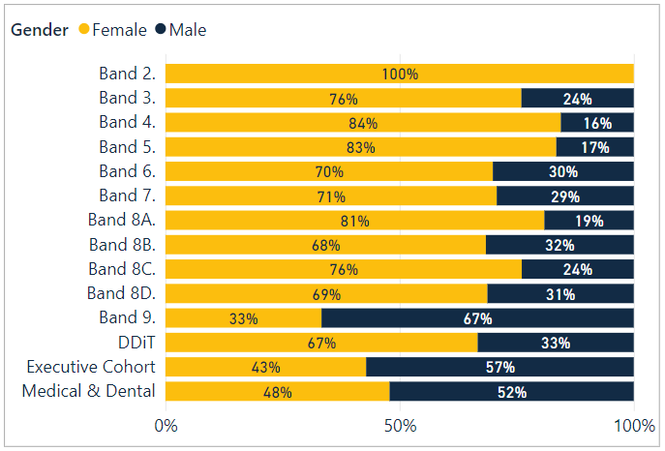

Figure 2: Working pattern by grade and gender for Males (all staff)

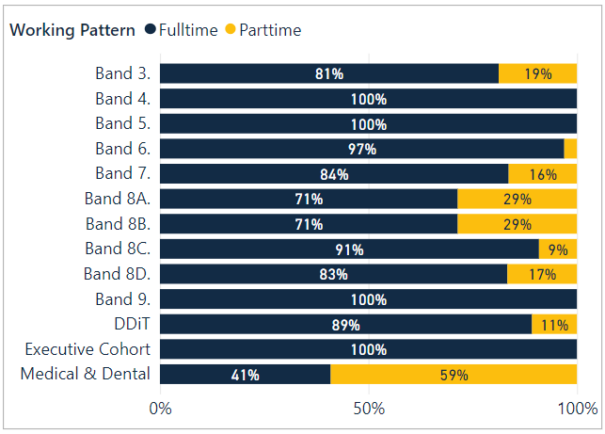

Figure 3: Working pattern by grade and gender for Females (all staff)

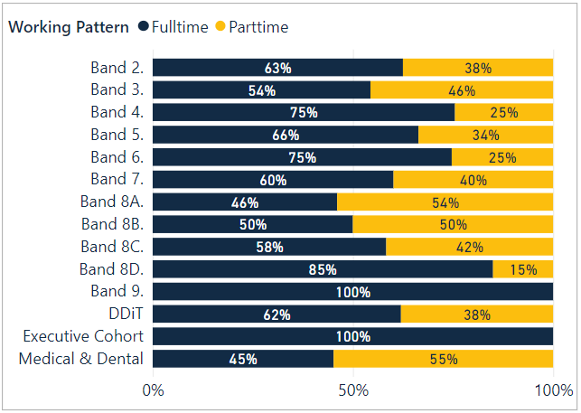

* For core staff, 38% (398) of the workforce work part-time, and a higher proportion of women (41%, 319 members of staff) work part-time compared to men (27%, 79 members of staff).
* Part-time workers are represented across most grades.
* The highest ratios are in band 8A to 8C and those on Medical and Dental terms and conditions.
* Full-time work is more common at Bands 4-6, and at band 8D and 9.
* The Executive Cohort of staff are all full-time.
* Part-time appointments are more common than full-time appointments in the Dental and Psychology Directorates. These include sessional staff who work part-time for NES in an educational capacity but often have clinical roles in NHS Scotland.
* Sex is almost an even split in the Medical Directorate.
* At less than 20% the Workforce, Finance and NES Technology Directorates have the fewest part-time workers.
* 62% of DDiT are female.

Additionally, we employ Consultant and Educator grade staff on part-time arrangements. For example, over 55% of the Consultant grade cohort, who are medical and dental educators, are part-time employees of NES, regardless of gender and will work for other parts of the NHS. Within Medical and Dental Terms and Conditions, staff can be on NHS Consultant and General Practice (GP) and General Dental Practice (GDP) or Educator contracts of employment. In NES this includes Associate Advisors.

## Ethnic Origin

Our core staff are primarily white (88%), with 4.5%% of staff identifying as being from a Black, Asian, Other ethnic backgrounds, or mixed ethnic background. Of the 88% who identified as White, 67% are White Scottish, and 14% are Other British.

The ethnic origin of 7% of NES core staff is unknown; this is where individuals have not disclosed this information (1.8%) or data is unavailable (5.2%). The data is not collected for certain types of workers, such as those on secondment agreements or agency contracts.

* 46% of ethnic minority staff are represented in bands 5 to 7
* 23% of ethnic minority staff are represented in bands 1 to 4.
* Ethnic minorities are under-represented in bands 7-8C and band 9
* 100% of the Executive cohort are White

Figure 4: Ethnicity (core staff)

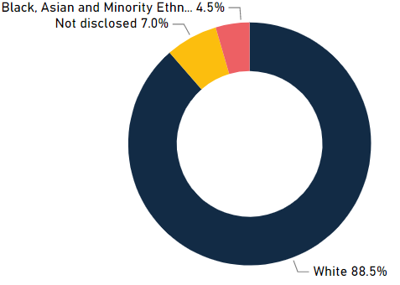

Figure 5: Ethnicity by Grade (all staff)

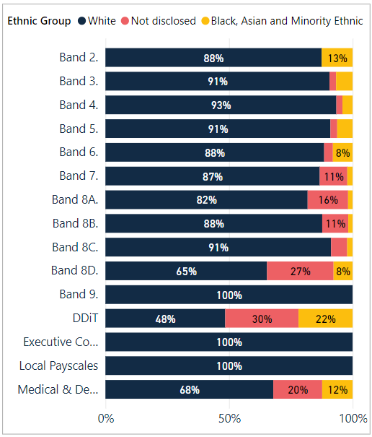

22% of DDiT have disclosed to be from Black and Minority Ethnic, mixed or other ethnic backgrounds. 31% have not provided data on ethnicity and this is a pattern that is seen across the protected characteristics in this cohort of staff.

A lack of equality and diversity data for DDiT (and the wider workforce) is an issue for other Health Boards and parts of the system. For example, the Scotland Deanery in NES, which works with Health Boards and GPs to provide training for all DDiT has undertaken a campaign to encourage all trainees to provide up to date equality and diversity information through the Turas platform. This led to an increase in completion of data and will be repeated in 2023.

Figure 6: Ethnic origin (DDiT)

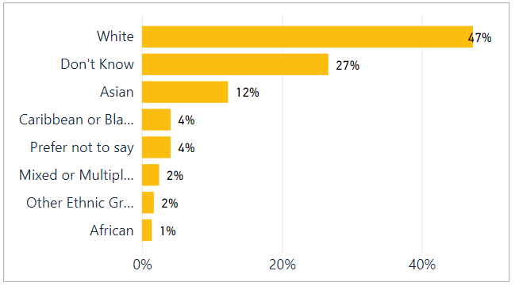

To put our workforce ethnicity data in context we set out below the most recent census data for the Scottish population and the wider NHS Scotland ethnicity profile.

According to the most recent census[3]:

* Scotland's population was 96.0% white, 2.7% of Scotland's population identified as Asian, Asian Scottish or Asian British.
* African Caribbean or Black groups comprised just over 1% of Scotland's population.
* Under 1% of Scotland's population identified as having a Mixed, Multiple or Other ethnicity.

NHS Scotland ethnic diversity is:

* 70% identified as White
* 2.5% identified as Asian, Asian Scottish or Asian British
* 0.74% identified as African, Caribbean or Black
* 0.86% identified as having Mixed, Multiple or Other ethnicity

However, these figures vary across job roles and Health Board areas with varying levels of completion rates across NHS Boards.

## Disability

Figure 7a shows that just over 3% of core staff identified themselves as disabled, 88% as not disabled and 8.5% preferred not to answer or where data was unavailable. Figure 7b shows the percentage of disabled staff in each age cohort. This shows that disability increases with age.

Figure 7: Disability (core staff)

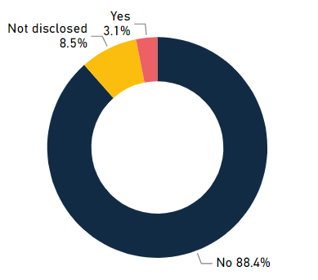

Figure 8: Disability by Age Group (core staff)

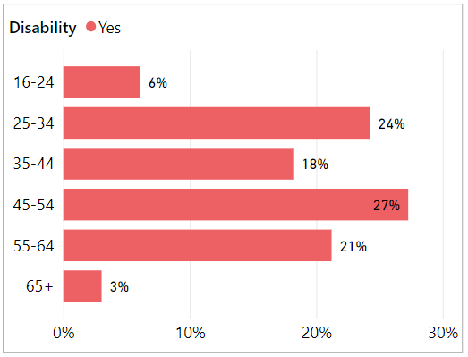

1.41% of DDiT identify themselves as disabled. The actual figure is likely to be higher given that 40.9% of DDiT have not provided information about disability status. This is higher than non-disclosure about ethnicity.

Our new specialist lead for Disability has a specific role to support our staff, including DDiT where we are the Lead Employer, with reasonable adjustments in the workplace. As identified above, work is required to encourage DDiT to complete equality and diversity monitoring to improve data and importantly the actions that we can take to progress equality for disabled people in the workplace.

## Age

* 79 % of core staff are aged between 35 and 64
* The highest % of core staff are aged 45-54 at 30.5%
* The lowest % of core staff are aged 16-24 at 1.9%

NES has a high number of posts requiring specialist skills or knowledge across various professional fields which may be a factor in low numbers under age 35.

Figure 9a: Age (core staff)

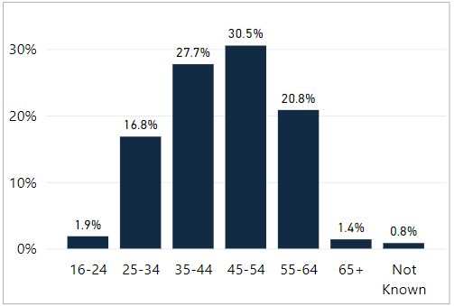

Figure 9b: Age (DDiT)

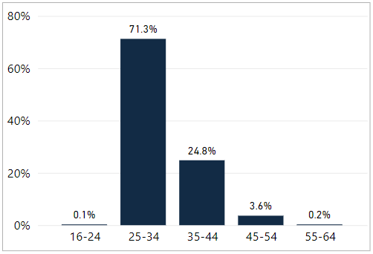

## Religion or Belief

Figure 10 sets out our employee data on religion and belief. NES’s core staff reflects a range of religious affiliations, although 'No religion' is the second most common identification at 45%, as compared with 36.7% in the 2011 census. Within the Christianity grouping, 20.4%% of core staff identified as Church of Scotland and 11.7% as Roman Catholic. Data has not been disclosed by 45% of the DDiT cohort. Where data is available Christianity (26%) is the largest grouping followed by No Religion (14%) and Muslim (8%).

Figure 10: Religion (core staff)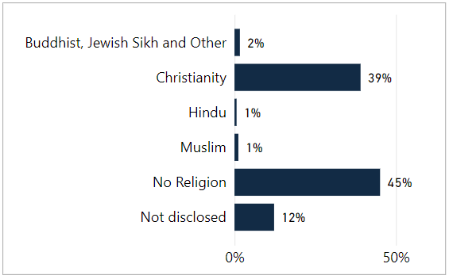

## Sexual orientation

* 3.9% of core staff identify as Lesbian, Gay or Bisexual
* 3.7% of Doctors in Training identify as Lesbian, Gay or Bisexual.
* The non-disclosure (Preferred not to answer or Not known) rate for core staff is 10.6% and for DDiT is 34%

Although this is data for England and Wales, the recently published [Sexual orientation, England and Wales - Office for National Statistics (ons.gov.uk)](https://www.ons.gov.uk/peoplepopulationandcommunity/culturalidentity/sexuality/bulletins/sexualorientationenglandandwales/census2021) reported 3.2% of respondents who completed this in the Census identified as LGB or other. Analysis for the Scottish Census has not been undertaken yet.

# RETENTION

We monitor employment policy related casework, disaggregated by protected characteristics, and the profile of staff who leave the organisation during the year, in case of any patterns emerging. We also carry out a thematic analysis of exit interviews.

Employment related casework is classified as formal management of a range of employee relations activities, including attendance management, disciplinary, grievance, bullying and harassment, capability and dismissal. We collect and analyse data on a range of activities.

20 formal employee relations casework events were recorded for core NES staff. 50% were related to conduct/disciplinary, 25% to grievance and 20% to capability. The number of formal cases is too small to permit disaggregated reporting by protected characteristics.

Our approach is to support early and informal resolution of issues where possible. We record informal employee relations support, which may involve advice to staff or managers around specific issues or policies. Informal support is not recorded against individuals and thus is not analysed by protected characteristics. This data does not include DDiT.

Between 01 April 2021 and 31 March 2022, 136 employees left NES (79 of whom completed the exit questionnaire). Of the leavers, 59.6% (N=81) were on permanent contracts, and 40.4% (N=55) were on fixed-term contracts. We collect and analyse data on NES core staff who leave the organisation. In the exit questionnaire, leavers are asked a range of questions concerning their experience working for NES. This includes the reasons for leaving (see Figure 11). As part of exit interviews, we also ask how fairly the respondents felt they were treated, how respected they were, what the attitude to diversity was like in NES and their satisfaction with the organisation when leaving.

* 76.2% of respondents did not feel that they had been disadvantaged on account of age, gender, sexual orientation, ethnic origin, religion, etc.
* Further work is required to understand those who did not respond positively to this question as part of the exit interview.

The attitudes of people leaving NES remain largely positive towards the organisation. 68.75% of the staff said they were either very satisfied (43.75%) or fairly satisfied (25%) towards the end of their employment with NES. 21.5% said they were fairly or very dissatisfied. Of those who said they were fairly or very dissatisfied:

* 59% (N=10) were female and 41%(N=7) were female
* 11.7% (N= under 5) were disabled
* 12% (N= under 5) were from a minority ethnic background
* 12% (N=under 5) were aged between 30-34 and 29% (N=under 5) were aged 60 or over
* 35% were Band 8B’s (N=6)
* 34%(N=27) were on fixed term contracts and 66%(N=52) were on permanent contracts.

Of core staff 28% are males but 66% of those dissatisfied with the organisation when leaving were male. Of the NES core staff 3.1% are disabled but 11.7% were dissatisfied. Of the NES core staff 4.5% were from a minority ethnic background but 12% were dissatisfied, this suggests disproportionality. Of those who said they were very or fairly satisfied:

* 24% were male and 24% were female
* 2% were disabled
* 4% were from a minority ethnic background
* 26% were aged between 55-64 and 24% were aged 35-44
* 19% were from Medical and Dental grades.

Figure 11: Leaving reasons (core staff)

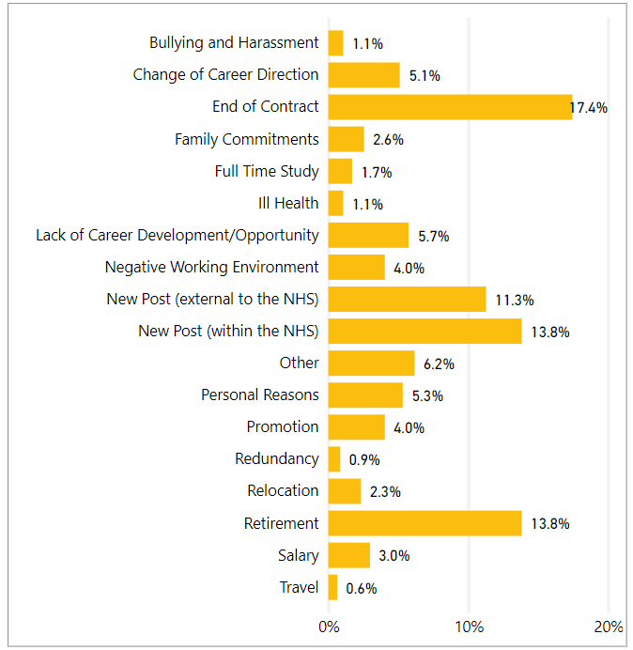

Appendix 1 provides a breakdown of the leavers diversity profile. Those leaving the organisation represent just under 10% of the core workforce.

* Males as a proportion of the workforce are more likely to leave the organisation than females (33% compared to 31% of the total workforce).
* There is a higher proportion of disabled employees leaving the organisation than non-disabled (4.6% compared to 3% of the total workforce advising of a disability)
* There is a higher proportion of staff in age groups 16-24, 25-34 leaving the organisation. This may reflect the stage in career in these age brackets.
* There is a higher proportion of staff in age bracket 55-64 and over 65
* 5% of leavers are from a minority ethnic background, slightly higher than the 4.5% of staff from a minority ethnic background in the workforce.
* 5% of LGBT staff left the organisation, which is a higher proportion than in the workforce (3%).
* There is slightly higher proportion of staff who have advised they are Christian leaving the organisation at 35% that who have advised they are Christian in the organisation (31.5%). There is a higher proportion of staff with no religion leaving the organisation at 50% than in the composition of the workforce (26.4%).

As we seek to increase the diversity of our workforce and progress equality for under-represented population groups, analysis of the proportion of staff who leave the organisation by protected characteristic to investigate possible reasons for this is important.

# STAFF DEVELOPMENT

This section relates to our core staff only. Education for DDiT is governed through their foundation, core or higher specialty training programmes and follows the curricula written by the Medical Royal Colleges and the Faculty of Dental Surgery and is approved and published by the General Medical Council and General Dental Council.

We analyse access to development for core staff by reviewing data on promotions, secondment or internal attachment, 'acting up' or temporary promotion and data on Training. Although our systems enable us to disaggregate all of the data by protected characteristics, some datasets (promotions, secondment/internal attachment, acting up) are quite small and permit only limited analysis.

## Promotions

A promotion within NES is defined as a staff member moving to a higher grade/band on a permanent contract. This report also includes temporary arrangements which provide a development opportunity for staff. By looking at promotions by protected characteristic we can identify if any groups are not experiencing equity in opportunity for career progression. This section does not include DDiT.

From April 2021 to March 2022, there were 98 promotions. Promotions were distributed across the organisation, with at least one in each directorate. A breakdown of promotion by protected characteristics is illustrated in Appendix 2.

* Almost 70% of promoted staff were women. This reflects the proportion of women in the organisation (69%)
* Men progressed more quickly than women overall (30 men with average 6.43 years' service vs. 68 women with average 8.27 years service)
* Staff aged between 25-54 accounted for 92% of promotions. Employees in 16-24 and 55-64 account for 8% of the promotions
* 6% were from a minority ethnic background. This is higher than the proportion of staff in the workforce who have advised they are from a minority ethnic background (4.5%)
* Just over half identified as 'no religion'
* 5% of the employees promoted identified as being disabled. This is higher than the proportion of staff declaring a disability in the workforce (3%).
* 5% of employees promoted identified as LGBT, which is higher than the proportion of LGBT staff in the workforce (3.9%).

## Training

We provide a range of staff development opportunities including work-based learning, e-Learning, attendance at conferences, staff panels and specialist learning events alongside a range of development courses and mandatory (essential) learning via our digital learning platform, Turas Learn. All courses housed on this system provide attendance/completion data. We also provide a range of self-directed learning as well as webinars and other digital learning offered directly to staff members via Microsoft Teams. These sessions are currently not logged against the individual learning record in Turas and we do not monitor rate of participation by protected characteristics.

# RECRUITMENT AND SELECTION

The outcomes for recruitment and selection of core staff are analysed in this section. DDiT are recruited through a national recruitment process for appointment to training posts across NHS Scotland (excludes Locum Appointments for Training). The standards and criteria for this process are set at UK level. Outcomes from this process are analysed separately at a national level and data for 2021/22 is currently being analysed and will be published at [https://medical.hee.nhs.uk/medical-training-recruitment/medical-specialty-training](https://eur01.safelinks.protection.outlook.com/?url=https%3A%2F%2Fmedical.hee.nhs.uk%2Fmedical-training-recruitment%2Fmedical-specialty-training&data=05%7C01%7Ckaty.hetherington%40nhs.scot%7C4befaa53674240e4382808daf7b78b92%7C10efe0bda0304bca809cb5e6745e499a%7C0%7C0%7C638094664931902139%7CUnknown%7CTWFpbGZsb3d8eyJWIjoiMC4wLjAwMDAiLCJQIjoiV2luMzIiLCJBTiI6Ik1haWwiLCJXVCI6Mn0%3D%7C3000%7C%7C%7C&sdata=%2BmuxYPxJ60jVPYhsczAeCplhrh3S9hPot94BWOIAljA%3D&reserved=0)

Appendix 3 summarises the overall number of applications and number of individuals shortlisted, interviewed and appointed to our core staff and applications by protected characteristic during the period 2021/22

## Attraction

We have revised and refined our approach to advertising posts, adopting a model which offered clearer and more precise information about the post and the skills and knowledge required in the person specification. A new style advert and job pack has been successfully piloted in 2022 and will now be rolled out across NES vacancies by end of March 2023.

Our vacancies will continue to be considered for internal advert in the first instance (i.e. to existing NES workers, including agency and secondments) before consideration is given to advertise externally. All vacancies pass through a robust corporate establishment control approval process prior to advertising, with data monitored at each stage of the recruitment cycle.

Data for 2021/22 indicates that 20% of applications were made by candidates from Black, Asian and Minority ethnic candidates. The diversity of applicants for posts varies across the organisation, with the greatest diversity of applicants for posts in the Digital, Finance and the NHS Scotland Management Training Scheme (which we administer). We have also seen an increase in ethnic diversity of applicants for consultant and medical educator posts and progression to appointment to these posts.

Applicant ethnic diversity was lower for posts in the fields of Nursing, Midwifery and Allied Health Professions. It was slightly below average in the Workforce directorate and low in the Planning & Corporate Resources, although there were a small number of applicants in comparison to other directorates.

We received 1360 (from a total of 7106) applications from applicants from Black, Asian and minority ethnic backgrounds. Applicants from Black, Asian and minority ethnic backgrounds have the most significant differential likelihood relative to those of white ethnicity of progressing from interview to appointment (18% vs. 26.6%) or from application to appointment (2.8% vs 5.6%). The likelihood of progression from application to appointment is almost double for White applicants compared to Black, Asian and minority ethnic backgrounds.

9% of applicants (N=640) for all posts identified themselves as disabled. In contrast, 91 (N=6466) of applicants identified as not disabled.

7% percent of applicants identified as LGBQT+ and 0.69% identified as 'other', which compares favourably with Stonewall Scotland's estimate of LGB people in the working age population. There is no significant difference between appointment rates of people who identify as LGB and those who identify as heterosexual.

Our applications represent a range of religious backgrounds and those identifying with no religion are most prevalent. We attract a similar percentage of applications from those identifying as Roman Catholic or Church of Scotland (12.31% and 10.23%, respectively, of the overall total number of applications). There is no significant difference in appointment rates between those identifying as Roman Catholic or Church of Scotland. The number of individual applications in most of the minority religions is too small for statistical analysis. 5.67% of applicants chose 'Prefer not to say'.

69.12% of our appointments in 2021-22 were women. Women formed most appointments across the organisations and at most grades, except that men were more likely to be appointed to consultant/educator posts. Appendix 2 illustrates the age distribution of applications for core NES posts. 44% of applicants do not complete information on age. Differences in appointment rate by age group are not significant after 'factoring out' our Management Training Scheme appointments, which attracted many applications for a small number of posts. These applications tend to be concentrated in the younger age bands. Management Training Schemes applications account for 63% of the 16-24 age band applications.

# GENDER PAY GAP

The Equality Act 2010 (Specific Duties) (Scotland) Regulations 2012[4] specify that public authorities must report the gender pay gap in the form of ‘information on the percentage difference among its employees between men’s average hourly pay (excluding overtime) and women’s average hourly pay (excluding overtime)’. The specific formula used for this calculation is the formula for the average pay gap set out in the guidance published by Close the Gap[5]. The specific formula is (A – B)/A X 100, where A = average hourly rate of pay of men and B = average hourly rate of pay of women.

Using this method of analysis, as of 31 March 2022 NES’s overall gender pay gap is 5.40%. The average hourly pay for women is £21.94 and for men is £23.17. Our current gender pay gap is below the Scottish public sector average of 12.5%[6].

TABLE 1: GENDER PAY GAP

|  |  |  |  |  |  |  |
| --- | --- | --- | --- | --- | --- | --- |
| This table provides a summary of the hourly pay rate and the gender pay gap for each contract group. The figures reported in this table show a comparison between women’s and men’s average hourly pay within the specific contract group. | | | | | | |
| **Pay scale** | **As of March 2017** | **As of March 2018** | **As of March 2019** | **As of March 2020** | **As of March 2021** | **As of March 2022** |
| Agenda for Change | 4.26% | 1.25% | 6.58% | 9.62% | 8.43% | 6.02% (893) |
| Executive Managers Cohort | 0.00% | -30.07% | -3.29% | -1.39% | -2.19% | -6.99% (7) |
| GP/GDP Eds, CRUMP and Consultants | 1.70% | 13.52% | 8.12% | 0.72% | 5.67% | 1.85% (121) |
| DDiT | -1.30% | -2.00% | -1.54% | 4.73% | -1.26% | -1.30% (1727) |
| **Grand Total** | **18.99%** | **27.56%** | **13.32%** | **7.28%** | **7.29%** | **5.40%** |
| Hourly Rate is calculated as ('Contracted Hours' x 52.179) / (Annual Salary * WTE) Senior Manager rate is based on grade step point, rather than personal salary value. | | | | | | |

In presenting the gender pay gap information, the nature of the calculations (based on average pay figures) means that the data is very susceptible to being skewed by large numbers of outlying pay levels. This is very relevant for the profile of the NES workforce. Over the course of the last two years NES has employed at large number of DDiT, which has contributed to reducing the gender pay gap.

# RECOMMENDATIONS

The analysis of our annual workforce data from 01 April 2021 to 31 March 2022 has informed the following recommended actions:

* Deliver a campaign to improve our annual workforce equality and diversity data following approval of a revised Equality and Diversity Form for all applicants through Jobtrain. This data will follow through if appointed for new recruits, but we recognise that data may change for staff in post e.g., disabilities may develop over time in the organisation.
* Deliver a specific campaign to encourage DDiT to update equality and diversity monitoring on Turas to improve our data collection and analysis for this cohort of staff. This will be undertaken following approval of the revised national Equality and Diversity Monitoring set of questions for NHS Scotland. It is dependent upon changes being made on Turas to reflect the new set of questions.
* Roll out and evaluate the impact of newly developed eLearning modules for staff involved in recruitment and selection. This incorporates guidance on bias, values-based recruitment, and our role to create an inclusive and diverse workforce.
* Analyse NES staff TURAS data by equality characteristic to improve our understanding of equity in opportunities for training and development in NES.

Employee monitoring is part of wider work at NES to progress equality, tackle discrimination and create an inclusive workplace for our staff. We have specific Equality Outcomes published in April 2021 to improve recruitment outcomes for younger candidates, minority ethnic candidates and disabled candidates. We will continue to provide progress reports through our Staff Governance Committee and to our Board on our Equality Outcomes.

Other actions we are taking to promote an inclusive, diverse and equitable workplace is reported in our Equality Outcomes and Mainstreaming Report, published in April 2023.

APPENDIX 1: Leavers profile (core staff)

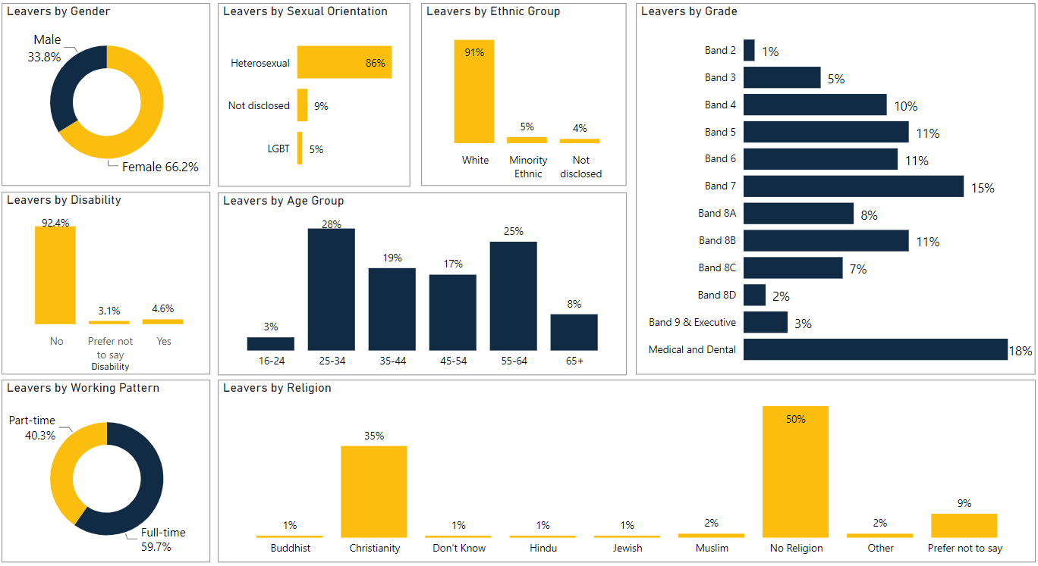

APPENDIX 2: Promotions profile (core staff)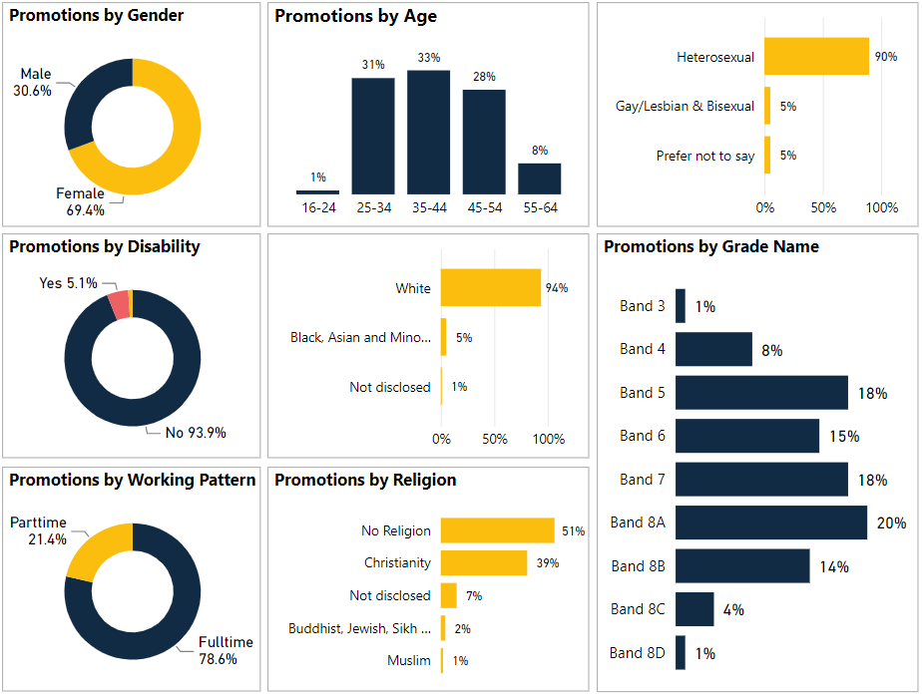

APPENDIX 3: Recruitment - Candidate profile (core staff)

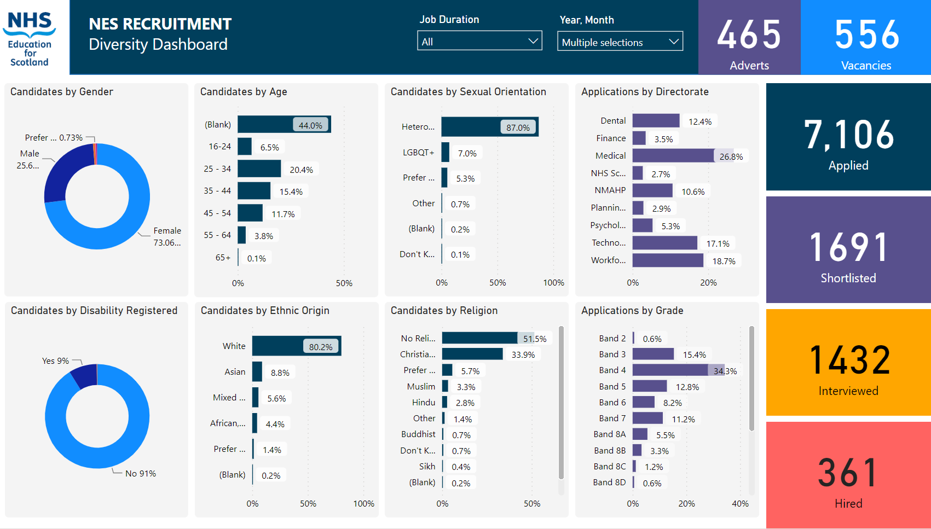

© NHS Education for www.nes.scot.nhs.uk Scotland [2023]. You can copy or reproduce the information in this resource for use within NHSScotland and for non-commercial educational purposes. Use of this document for commercial purposes is permitted only with the written permission of NES

**NHS Education for Scotland**

**Westport 102**

**West Port**

**Edinburgh**

**EH3 9DN**

This resource may be made available, in alternative formats and community languages. Please contact us on **0131 656 3200** or email **altformats@nes.scot.nhs.uk** to discuss how we can best meet your requirements.

1. For Data Protection reasons we are not allowed to report on any categories if there are under five staff present in that category
2. We refer to all staff employed by NES who are not employed as Doctors or Dentists in Training and working in NHS Boards as part of their training as core staff. This includes a variety of roles across our organisation.
3.
4. [The Equality Act 2010 (Specific Duties) (Scotland) Regulations 2012 (legislation.gov.uk)](https://www.legislation.gov.uk/sdsi/2012/9780111016718/contents)
5. https://www.closethegap.org.uk/content/resources/Gender-pay-gap-statistics-paper-2022.pdf
6. [CTGBriefing24 (closethegap.org.uk)](https://www.closethegap.org.uk/content/resources/Gender-pay-gap-statistics-paper-2022.pdf)