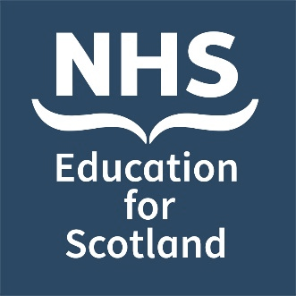
Date: Tuesday 3 December 2024
International Bereavement Education Conference 2024
Parallel Session Abstract Submission Form
Venue: Virtual

Invitation: You are invited to submit abstracts for the hosting of parallel sessions as part of the NHS Education for Scotland (NES) international virtual bereavement education conference:

Bereavement in the modern world: Kindness in the chaos

#NESBereavement2024

NES is very pleased to be hosting its fifth bereavement education conference on 3 December 2024. This one-day event will be relevant to all health and social care staff.

Submissions are welcome from those working within Scotland and internationally, and from all sectors including health and social care services, integration authorities, voluntary and partner organisations and other public or private sector organisations. We expect parallel sessions to run for approximately 50 minutes.

Parallel session categories: We invite submissions of parallel sessions covering any aspect of innovation and creativity leading to improved outcomes:
- for those who are bereaved and / or
- for staff who experience death and bereavement in the course of their work.

These may include aspects of education, service delivery and quality improvement relevant across a wide spectrum of bereavement related situations. We are also happy to accept work that has already been presented at other events.

Successful abstracts will demonstrate:

- How your work makes a difference – evidence of impact and how your efforts lead to improved outcomes.
- A brief overview of the format for your session

Abstract template: Please use the abstract template on the following page to complete your submission and send your completed form to events@nes.scot.nhs.uk. Please also direct any queries or requests for further information to this email address.

Proposed title of Parallel Session:
Lead Presenter details: | Name:
 | Job title:
 | Organisation:
 | Email address (Please provide a work email address where possible):
Affiliation / institution where the work has been carried out:
Details of other Presenter(s) – please include, name, job title, organisation:
If we are unable to offer you a parallel session within the conference programme, please indicate if you would be interested for your abstract to be considered for poster presentation, to enable you to showcase your work on the NES Support Around Death website. |  | Yes ❒
 |  | No ❒

Abstract text
Parallel session description (this will be published on the NES conference website to inform delegate selection - max 150 words):

Please list the objectives of the parallel session, indicating the knowledge and skills participants should expect to gain (max 150 words):

Please email your completed form to events@nes.scot.nhs.uk no later than 12 noon BST on Fri 12th July. We would hope to contact you between 2-4 weeks after the closing date.

Further information about the conference can be found at https://www.nes.scot.nhs.uk/events

