
AHP Projects Progressing PrBL
Quality and Governance

Jo Teece and Rachel Tainsh, 2025

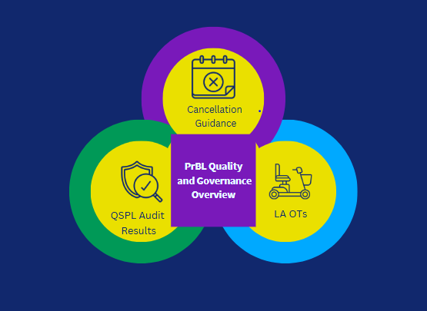

Situation / Background to project

Purpose
To enable workforce growth across all sectors, Allied Health Professional (AHP) students need diverse, high-quality Practice Based Learning (PrBL) opportunities in Social Care, the Third Sector and Health settings across Scotland.

Objective
Within the Quality and Governance workstream, the aim is to enhance the learning environment through strong governance and processes that support sustainability and growth, aligning with the Scottish Government Education and workforce review .

Scope of project
The Quality and Governance Progressing PrBL project had 3 components:
- National guidance for managing AHP student cancellations
- Quality Standards for Practice Learning (QSPL) Section 4 Audit Results
- Focus on PrBL within Local Authority (LA), Occupational Therapy (OT) settings
This report will focus on component 3 (PrBL in LA OT) with a brief overview of 1 and 2.

1. National guidance for Managing AHP Student Cancellations
These refreshed guidelines help ensure a consistent process to support communication of cancellations between the practice setting, the learner, and the Higher Education Institutes (HEIs), as well as supporting risk management.
Actions
- Umbraco was chosen as the host digital platform, as it is accessible across multiple devices within health and care and third sector settings. Case studies and an evaluation tool were added. Collated feedback will inform an ongoing cycle of improvement to maintain the contemporary nature of the guidance. A communication plan was agreed and promoted with stakeholders.

2. QSPL (PrBL) Section 4 Audit Results
In January 2024, 22 Health boards across Scotland were invited to complete an audit of QSPL Section 4. Nineteen completed audits were returned. Section 4.9 was identified as an area where a national approach could further support implementation.
Actions
- A detailed report on Quality Standards for Practice Based Learning Section 4 Audit Results and Resulting Actions to Progress Standard 4.9. can be accessed here
- An online CPD session (How to ensure service users are actively involved as individuals who support learners) was attended by 104 participants.
- The theme of involving service users will be included on the Turas AHP pages with links to tools and useful resources.
- Ongoing work should explore what else could build practice educator skills and confidence to involve service users in their day to day practice and PrBL.

3. Focus on PrBL within Local Authority settings

Identification of stakeholders

Engagement work by the NHS Education for Scotland (NES) AHP practice education team had identified AHP networks for OT within local authority settings. These included senior leaders, the professional body, HEIs, and practice educators (PEs).

Scoping
Project scoping was supported by a number of tools including: a problem tree, a weavers triangle and iterative questioning. This resulted in the production of a cause and effect fishbone diagram (Appendix 1) which helped to theme the key challenges and provide the focus of what was in scope for a practice based learning project.

Key Findings
- OT students face limited and inconsistent PrBL placements in local authorities, reliant on a few key Practice Education champions.
- Unique barriers and opportunities exist for local authority OTs within PrBL and practice education is part of broader sector challenges.

LA OT PrBL Project Purpose
- Better understand the landscape and identify and upskill new and existing LA PEs
- Increase the number of LA OT PrBL placements across Scotland

Objective
To identify and support new PrBL opportunities in LA settings we worked in partnership with key stakeholders to create opportunities for existing and new practice educators to attend bespoke events that will address their unique setting and development needs.

Actions/ Outputs
- A face to face and online event were held in partnership with the 4 HEIs involved in pre registration OT training
- The events adapted NES branding and used intentional language - Voices Together – Local Authority OTs Matter
- The HEI face to face session offered networking, PrBL literature, virtual reality (VR) headset demonstrations, SIM facility tours and NES Social Care Directorate (SCD) Unpaid Carers Team involvement.
- Speakers included occupational therapists with experience of working in local authority settings. In addition, Gordon Patterson, NES SCD Director spoke at the online event.
Impact
Engagement Impact
- 10% of the OT LA workforce, across 15 local authority areas, engaged with the 2 educational events
- A blog, “ Local Authority Occupational Therapists Matter” promoting the role of LA OTs in PrBL was published to support AHPsDay.
- Bespoke branding, intentional inclusive language (Figure 1) and co-creation of a new image representing OT (Figure 2) in local authority supported engagement
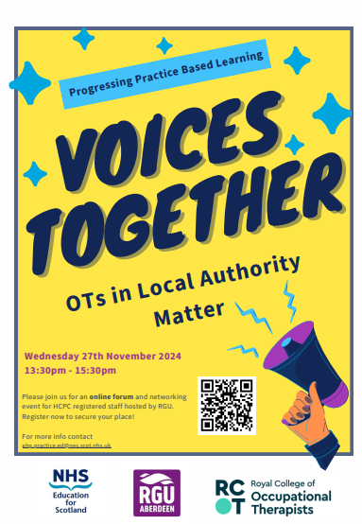
Figure 1 Poster Advertising an event
Figure 2 Owen LA OT

Educational Impact
Post evaluation surveys of OT practice educators who attended the face to face and online workshops reported increased confidence and motivation towards PrBL.

Performance Impact
Differing alignment of the NES funding cycle for the PrBL project and apportionment mean it is too early to state whether there has been a change in placement offers from LA settings. Glasgow Caledonian University hosted a bespoke PE training in February 2025 and reported a placement offer from one area that has not engaged recently and new offers from another.

Lessons Learned
Many lessons have been learned. The importance of using inclusive understandable language that supports participation has been key. OT students have shared that they highly value the learning that they gain in a local authority setting. LA OT practice educators recognise that offering PrBL opportunities supports future recruitment and enhances both their own and their teams learning and development.
This work is still in it’s infancy and many practice educators feel isolated and ‘out of sync’ with their NHS AHP colleagues who are using ‘new models’ and have had more opportunities for training and support. Relationships across the sector need to be nurtured, LA OTs actively included in key NES PrBL stakeholder groups and assured that they are valued.
It is difficult to separate PrBL from the wider workforce issues that are experienced by LA OTs. New legislation and the changing landscape of health and social care provision mean that there is an increasing need to advocate for their key role in early intervention/prevention in social care. Building diverse PrBl opportunities for OTs, including local authority settings, is crucial for the future of health and social care.

Recommendations
- NHS Education Scotland (NES) actively seeks to build on the project gains, involves LA OTs in strategic groups, ensures language is inclusive and understandable and works to further highlight the unique contribution of LA OTs in relation to PrBL.
- NES creates a LA OT reference group to support the further role out of actions in relation to PrBL in LA settings.
- NES supports the AHP Practice Education Leads to understand and respond to the unique landscape of PrBL in LA settings.
- NES works with LA OT stakeholders and HEIs to develop LA OT PE spotlight training sessions that will highlight a team approach to PrBL (including involving service users) and explore the use of models.
- NES continues to identify where cross directorate work will support LA OTs in relation to PrBL but also wider workforce pressures.
Appendix 1 – Fishbone Cause and Effect Tool A fishbone diagram is a visual way to look at cause and effect. The problem or effect is displayed at the head or mouth of the fish. We used this tool to identify the drivers that impact PrBL in LA OT settings.

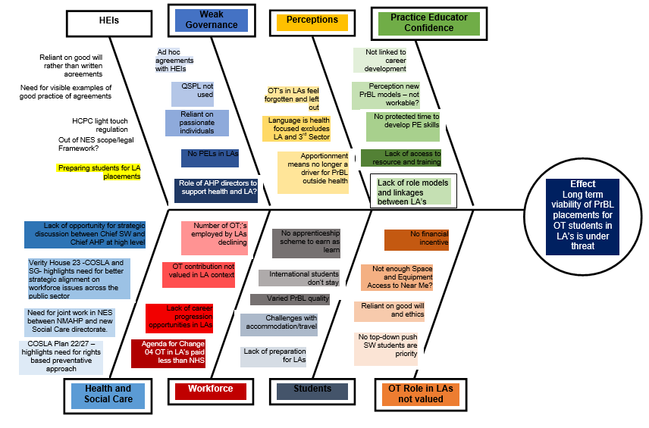


NHS Education for Scotland
Westport 102
West Port
Edinburgh EH3 9DN
tel: 0131 656 3200
www.nes.scot.nhs.uk
© NHS Education for Scotland 2024. You can copy or reproduce the information in this resource for use within NHSScotland and for non-commercial educational purposes. Use of this document for commercial purposes is permitted only with the written permission of NES.

This resource may be made available, in full or summary form, in alternative formats and community languages. Please contact us on 0131 656 3200 or email altformats@nhs.scot to discuss how we can best meet your requirements.

