Bereavement Education Conference
From the Shadows: Shedding Light on Bereavement at the Margins
Poster Abstract Submission Form

Wednesday 11 November 2026

Invitation: You are invited to submit poster abstracts for the Public Services Delivery Scotland bereavement education conference.
https://www.nes.scot.nhs.uk/events
#PSDSBereavement2026
We are very pleased to be hosting the seventh bereavement education conference on 11 November 2026. This one-day event will be relevant to all health and social care staff.
Submissions are welcome from those working within Scotland and beyond, and from all sectors including health and social care services, integration authorities, voluntary and partner organisations and other public or private sector organisations.
Poster categories: We invite submissions of poster abstracts covering any aspect of innovation and creativity leading to improved outcomes:
- for those who are bereaved and / or
- for staff who experience death and bereavement in the course of their work.
These may include aspects of education, service delivery and quality improvement relevant across a wide spectrum of bereavement related situations. We are also happy to accept work that has already been presented at other events.
Abstract template: Please use the abstract template on the following page to complete your submission and send your completed form to events@nes.scot.nhs.uk. Please also direct any queries or requests for further information to this email address.
Key dates:
Deadline for poster abstract submissions | Monday 7th September at 12 noon BST
Lead authors will be notified whether their abstract has been selected by | Friday 25th September

Poster title:
Lead Presenter details: | Name:
Lead Presenter details: | Job title:
Lead Presenter details: | Organisation:
Lead Presenter details: | Email address (Please provide a work email address where possible):
Affiliation / institution where the work has been carried out:
Details of co-author(s) – please include, name, job title, organisation:

Abstract text (300-word limit) – You may find it useful to utilise the following structure (Introduction, Methods, Results / Discussion, Conclusion) but this is not mandatory.

Please submit your completed abstract form to: events@nes.scot.nhs.uk
Submission deadline: 12 noon BST on Monday 7th September 2026

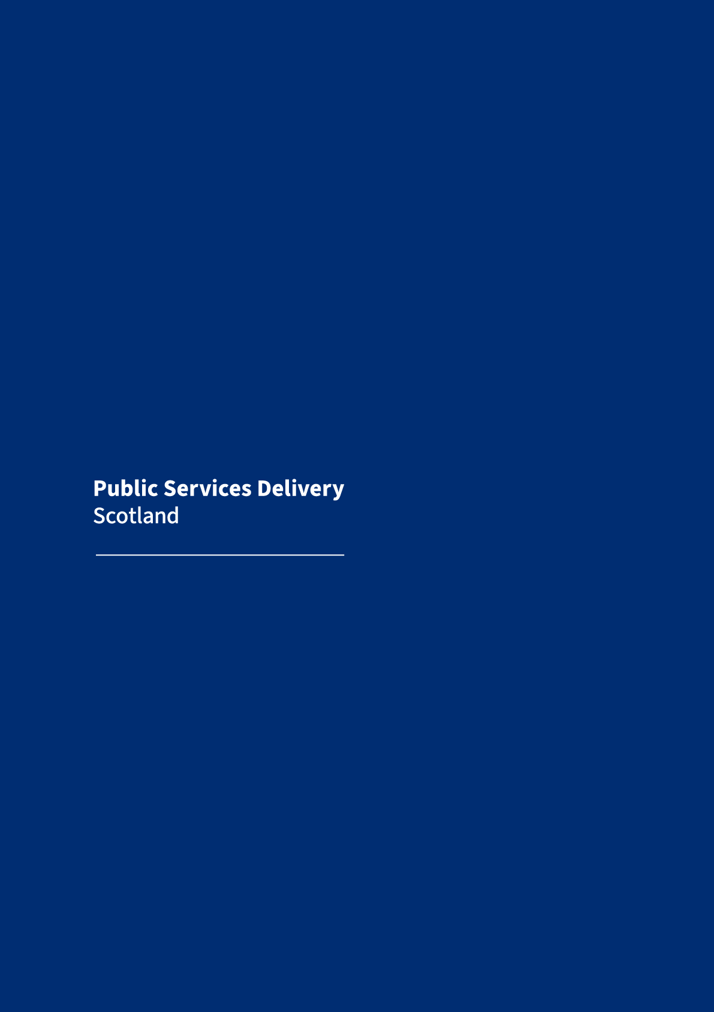

PSD Scotland
Gyle Square
1 South Gyle Crescent
Edinburgh
EH12 9EB
Tel: 0131 275 6000
www.publicservicesdelivery.scot
©PSD Scotland 2026. You can copy or reproduce the information in this resource for use within NHS Scotland and for non-commercial educational purposes under creative commons CC BY-NC 4.0 Deed | Attribution-Non Commercial 4.0 International | Creative Commons. Use of this document for commercial purposes is permitted only with the written permission of PSD Scotland.

