
AHP Projects Progressing PrBL
Arts Psychotherapies

Kassandra e'Silva & Megan Hatcher, 2025

Situation / Background
This project is part of the NHS Education for Scotland (NES) Allied Health Professions
(AHP) Projects Progressing Practice-based Learning (PrBL), commissioned and funded by the Scottish Government. The Arts Psychotherapies were identified to benefit from continued investment to support the development of PrBL in Scotland. For clarity, Arts Psychotherapies is the collective name for Dramatherapy; Art Psychotherapy, Music Therapy and Dance Movement Psychotherapy. This is a group of psychological therapies that use different creative modalities within their therapeutic process. Currently in Scotland there are PrBL opportunities for art, music and dramatherapy.

Arts Psychotherapies PrBL Context

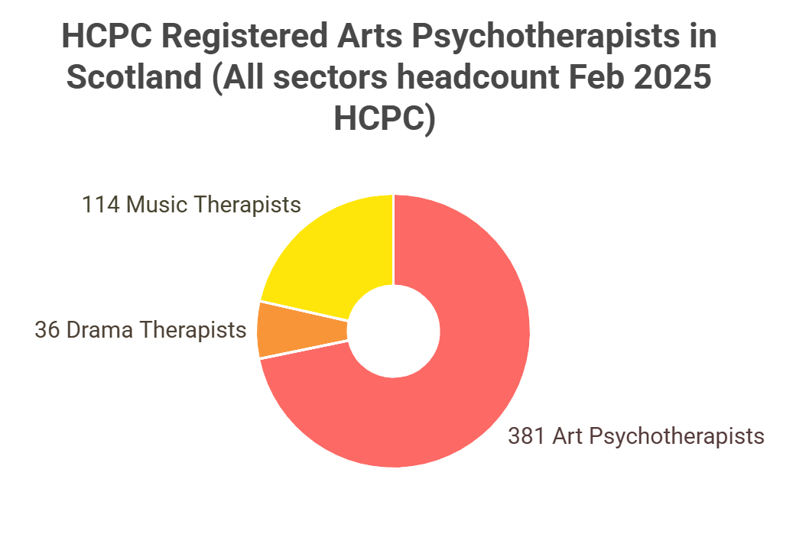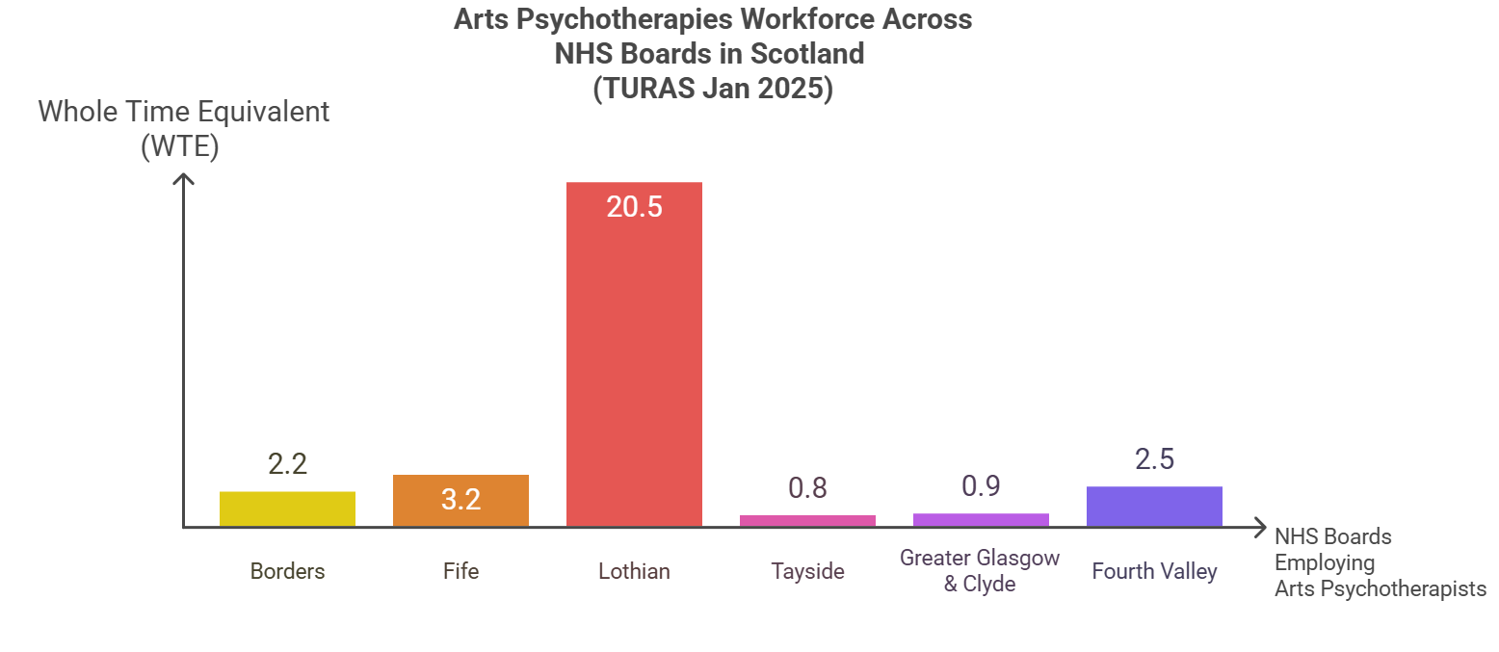
Figure 1 Figure 2

HCPC data highlights that the Arts Psychotherapies are a group of smaller AHP professions in Scotland. Turas data shows variable numbers employed across NHS health boards and highlights that most Arts Psychotherapists work out with the NHS in Scotland. There are no Dramatherapists employed by NHS health boards currently, but there are Dramatherapy trainees (students).

Key placement requirements relevant to PrBL landscape:
- All Arts Psychotherapies training in Scotland is post-graduate (MSc) at Queen Margaret University (QMU), with full time and part time options.
- All trainees are required to undertake 2x 6-month placements (full time two days a week, part time 1 day per week).
- There are different PrBL requirements across the years and modalities.
- All placements could be described as long-arm supervision as students are supervised weekly through Queen Margaret University (Dramatherapy Year 2 trainees are required to find external Dramatherapy supervisor).
- Trainees are expected to attend QMU in person once a week which poses challenges to development of placements outside the central belt, there is no current funding for travel.
There are a lack of placement offers in NHS territorial boards beyond the central belt which could equate to a lack of Arts Psychotherapies positions within the workforce of those boards. PrBL is essential to developing the future Arts Psychotherapies workforce nationally and there is a need to increase numbers and confidence of practice educators across sectors and geographical locations so that placements are available when required.

Task April 2024- March 2025

The Arts Psychotherapies PrBL project focus was capability and capacity. The tasks for this project were based on recommendations from Phase 1 found here:
AHP PrBL Recovery Arts Therapies Report 2023.

Phase 2 Objectives:
- Increase awareness and engagement with Arts Psychotherapies specific PrBL resources including the Practice-based Learning Support Package for NHS Placements hosted on Art Psychotherapy | Practice Based Learning Website | Queen Margaret University Music Therapy | Practice Based Learning | Queen Margaret University, Edinburgh, national PrBL resources (NES and Turas) and CPD opportunities for Arts Psychotherapists working across sectors.
- Increase placement opportunities for arts psychotherapies trainees.
- Complete the Quality Standards for Practice Learning (QSPL) Section 3 Audit by November 2024 in collaboration with stakeholders: quality_standards_for_practice_learning_qspl.pdf
- Explore NES PrBL PEL role in supporting integration between the modalities and facilitate national peer support networks (Art/Drama/Music Therapy). Develop a growing network of practice educators in NHS boards who are ready to take on learners by September 2025.

Stakeholders:
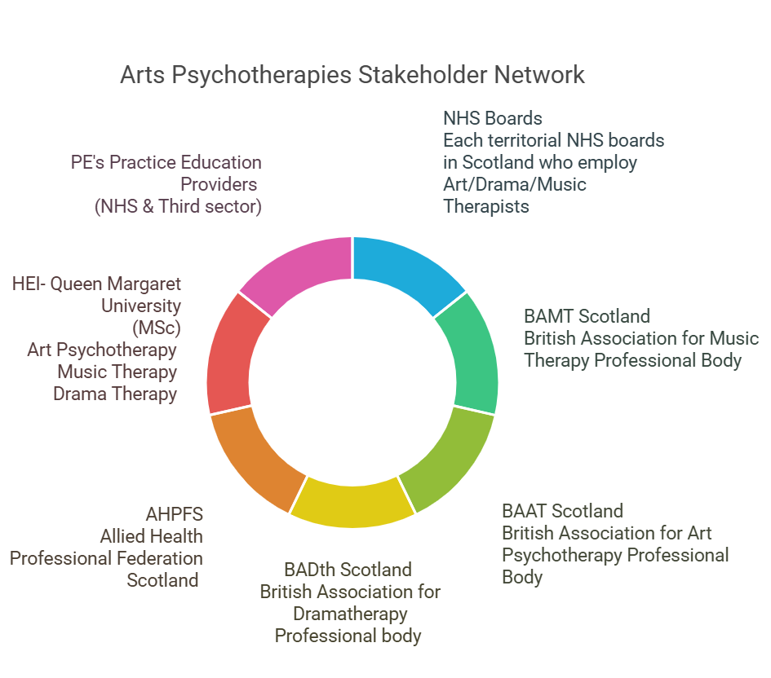
Figure 3
Engagement with stakeholders has been essential to ensure working collaboratively towards project objectives. Varied methods such as surveys, scoping activities, feedback questionnaires and CPD events have been used to establish effective communication channels. It is important to note that due to the small numbers within the Arts Psychotherapies NHS workforce, it was felt that no separate PrBL group was required and the project lead engaged utilising existing infrastructure in the form of NHS strategic groups and forums.

Actions/ Outputs

Actions | Intervention
Scoping | Refining understanding of challenges facing the Arts Psychotherapies in Scotland through stakeholder engagement highlighted in phase 1 recommendations.
Engaging with stakeholders | PrBL agenda items discussed at meetings of existing Arts Therapies strategic groups and forums with representation from territorial boards/employers of Arts Psychotherapists, representatives from AHP Federation Scotland (AHPFS) and professional bodies of each modality.
Arts Psychotherapies PrBL networking development | Robust communication strategy and joined up thinking between Arts Psychotherapies project lead and stakeholders to enable links to be made between new placement providers and higher education institute (HEI).
Arts Psychotherapies PrBL Resource engagement | PrBL resources hosted on QMU PrBL zone for Art and Music Therapy (Dramatherapy website still in development). Shared with new placement providers prior to their learners arriving and gathered feedback.
CPD Event (Engagement with resources) | British Association of Music Therapy (BAMT), British Association of Art Therapists (BAAT) and Dramatherapy Scotland Building the DAM: Progressing Practice Based Learning for Arts Therapies in Scotland online event. Signposting to AHP Practice Development Framework, introduction to Turas and the virtual community.
Quality Standards for Placement Learning (QSPL) section 3 audit | Collaboratively gathered and collated evidence from placement providers of Arts Psychotherapies and the Higher Education Institute representatives to better understand adherence to the QSPL section 3 standards.

Impact

Capability
Qualitative data gathered through evaluation of the Arts Psychotherapies PrBL support package continues to highlight an increase in:
- Confidence and preparedness to become a practice educator (PE)
- Colleagues accessing and using resources with learners in practice (NHS)
- Reporting by Arts Therapies Practice educators that they feel more connected to the national PrBL landscape and strategic picture

Feedback from Arts Therapies practice educators:
‘I have found the resource very helpful and it offered my a greater sense of reassurance that I was following a recognised and approved standard of student support. Prior to accessing the resource I spent considerable time gathering information and making up my own induction process for students- to have this collated for me in one easy to access location was wonderful.’

‘I have found the resource to be very helpful- I wish I had known about it sooner. I have downloaded all the individual elements of the resource and anticipate making regular use of the resources with all future students from arts background. I like how it keeps referring back to HCPC Standards’

In addition, the CPD event ‘Building the Dam’ outcomes and feedback highlighted appetite from clinicians from across the modalities to come together, share experience and learning in relation to PrBL and to connect to the bigger strategic picture across Scotland. Particpants reported increased motivation and confidence to support student learners following the session:
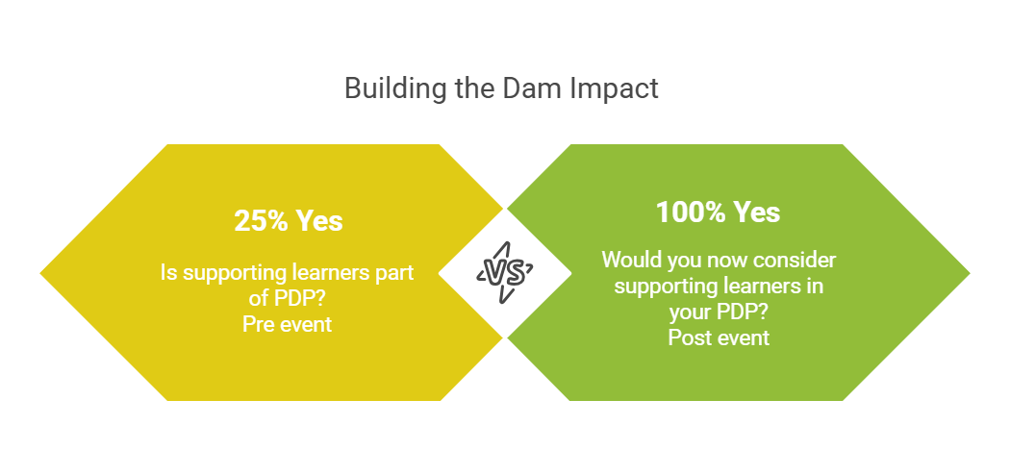
Figure 4
QSPL Audit Section 3
It is significant that this has been completed in a collaborative way with stakeholders. This will encourage a more strategic and coordinated approach that promotes consistency in governance, shared understanding of requirements, and acts as a shared quality assurance mechanism across NHS, HEI and between the modalities.
Key recommendations from the audit include:
- PrBL to remain a permanent agenda item at strategic group
- Develop standardised process for receiving and reviewing feedback from students- aligning with AHP PrBL Qualtiy and Governance workstream within QSPL Section1
- Include PrBL CPD opportunities within personal development plans for practice educators

Capacity
There has been growth of the Arts Psychotherapies PrBL network within NHS boards and connections made to offer new placements. In the period 2024- 2025, three new placements were developed. This included NHS Highland and NHS Forth Valley supporting Dramatherapy trainees, and NHS Lanarkshire hosting an Art Psychotherapy trainee for the first time. These placements utilised a long arm supervision model. NHS Ayrshire and Arran and NHS Fife are looking to support placements for 2025-2026 in varied clinical settings, some role emerging. Barriers around location and travel have been overcome through dynamic collaboration between the HEI and NHS boards, and with consideration to students’ base. I.e. trainee in NHS Highland could complete placement there due to their home base being there.

Integration between the modalities and facilitate national peer support networks
Although small, there has been growth of Arts Psychotherapists within the AHP PrBL Virtual Community, increasing from 7 to 15 members across 2024-2025 Quarters 1-3. It is hoped that this space will function to continue to support, nurture, celebrate best practice and maintain PrBL agendas for Arts Psychotherapists across sectors.
Learning / Recommendations
Collaboration between the existing Arts Therapies strategic groups and forums, NES and other stakeholders is key to supporting ongoing progress for PrBL development and quality improvement within the Arts Psychotherapies. To strengthen the PrBL focus within the Arts Psychotherapies workforce this projects recommendations are as follows:

- Stakeholders to progress collaborative actions agreed in the QSPL Section 3 Audit and explore the role of NES AHP practice education programme in supporting facilitation of future audits.
- The Scottish AHP wide PrBL infrastructure including Turas learn and the AHP PrBL Virtual Community should continue to enhance inclusion of the CPD needs of Arts Psychotherapies educators across all sectors. This remains highly relevant within the Arts Psychotherapies professions where the majority of the workforce are employed outside the NHS.
- To continue to increase PrBL capacity, including out with the central belt, it is recommended to explore opportunities for collaboration with AHP colleagues where they arise to develop more diverse PrBL models such as Peer assisted learning (PAL) and role emerging placements. This, along with the national apportionment work ongoing, may assist inovercoming challenges around geographical location and help to progress towards a more equitable Arts Psychotherapies workforce across NHS Scotland health boards.
- Practice-based Learning Support Package for NHS Placements to continue to be evaluated and developed through use in 2025-2026 placements,with particular attention to dramatherapy requirements.
- Aim to continue to increase the visibility of the Arts Psychotherapies within wider AHP networks and NHS Education for Scotland to support Arts Psychotherapies inclusion in national PrBL strategy and strategic development in Scotland. There have been significant benefits for the Arts Psychotherapies having a PEL to highlight additional considerations and complexities for PrBL in these professions.


NHS Education for Scotland
Westport 102
West Port
Edinburgh EH3 9DN
tel: 0131 656 3200
www.nes.scot.nhs.uk
© NHS Education for Scotland 2024. You can copy or reproduce the information in this resource for use within NHSScotland and for non-commercial educational purposes. Use of this document for commercial purposes is permitted only with the written permission of NES.

This resource may be made available, in full or summary form, in alternative formats and community languages. Please contact us on 0131 656 3200 or email altformats@nhs.scot to discuss how we can best meet your requirements.

