GENERAL NURSING COUNCIL FOR SCOTLAND (EDUCATION) FUND 1983 AND MARGARET CALLUM RODGER MIDWIFERY AWARD

SCHOLARSHIP APPLICATION FORM
2021-22 DISBURSEMENT

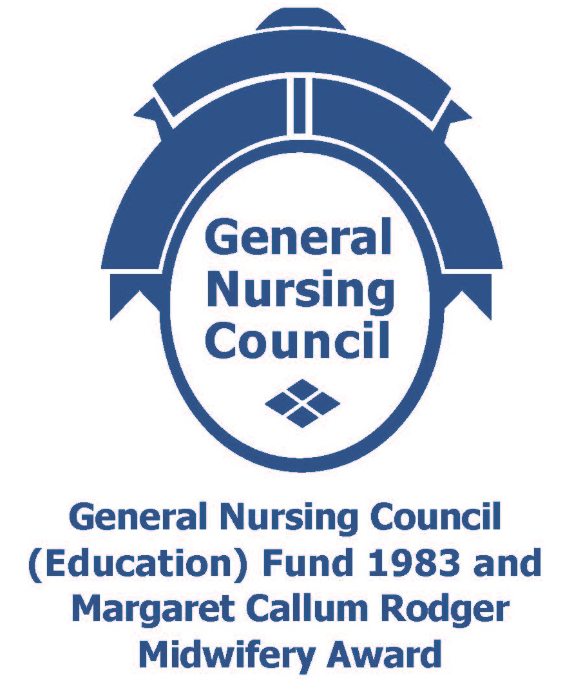

PART A – TO BE COMPLETED BY ALL APPLICANTS

All applications must be typed in 12 size font using 1.5 line spacing.
Note: All applicants should read ‘Scholarship Information for applicants (including Conditions of Scholarship)’ in conjunction with completing this form.

Personal Details (see note 1)
Full Name: |  |  | Title:
Address:
 | Postcode:
Telephone: |  | Mobile (if applicable):
Email:
NMC PIN Number:
Current Employer:
Current Post:
Workplace Address:

Previous Applications to the GENERAL NURSING COUNCIL FOR SCOTLAND (EDUCATION) FUND 1983 AND MARGARET CALLUM RODGER MIDWIFERY AWARD (see note 2)

Have you previously applied to this fund?
If so, what year did you last apply?
Was your application successful?

Proposed Activity
Title of proposed activity (see note 3):
Purpose of proposed activity (see note 4): | Educational Development Activity
 | Small Scale Project
 | Study Tour
Expected start date and duration of activity (see note 5):

How do you anticipate that learning from your education activity will inform issues of equality and diversity? (see note 6)

Financial details (see note 7)

Please detail the total amount of financial support required from the GNC Fund.

Please provide below a breakdown of the expenses anticipated:
Expense Description |  | Cost | Is this an Estimated cost? | Anticipated payment date
Item 1 |  | £
Item 2 |  | £
Item 3 |  | £
Item 4 |  | £
Item 5 |  | £
TOTAL (this total should be the same as the Total Amount of financial support requested from the GNC Fund) |  | £

Have you requested funding from elsewhere? | YES NO
Has funding been confirmed? | YES NO
If YES, please detail all the amounts including the name of the source: (see note 8) | Awarding body | Amount awarded

Risk Assessment (see note 9)
Detail the risks and the management plan identified.
Risk | Measures of Mitigation | Likelihood | Impact | Action
1.
2.

Submission of Final Report (see note 10)
Please give the anticipated date when the final report of the project will be submitted to NES:
Anticipated date of submission of final report:

Curriculum Vitae (CV)
All applicants must attach a full up-to-date CV.

Consent Form
All applicants must complete the Consent Form (Appendix 1 – separate document) and return a signed copy to NES with your completed application. Applicants are providing consent for final reports to be uploaded to the NES website.

Additional Support (see note 11)
If applicants require any support in completing this application form please contact any of the contacts detailed within Note 11 of the Scholarship Information for Applicants.

Signatures

Applicant
I certify that to the best of my knowledge the details in this application are correct.

Applicant’s signature (see note 12):

Line Manager
I have read and understand the conditions of the award and support this application. I agree to monitor submission of final report following completion of educational development activity as a requirement of funding. I agree to being included in any communication regarding non submission of said report.

Supporting signature from line manager (see note 10 and13):
Line manager name:
Line manager role/job title:
Line manager contact details | Email: | Tel:

Applicants should proceed to complete either:
- Section 1 (for Educational Development Activity)
- Section 2 (for Small Scale Project
- Section 3 (for Study Tours)
SECTION 1 – TO BE COMPLETED FOR EDUCATIONAL DEVELOPMENT ACTIVITY APPLICATIONS ONLY

Title of Proposed Educational Development
(see note 14)

1. Nature & Rationale: Please provide information on the nature of the proposed Educational Development Opportunity and the rationale for selection. Maximum 300 words

2. Aim and potential outcomes: Please provide the aim and expected potential outcomes relating to your practice

3. Expected Benefits for Patients/Service User/Client Group (please list):

4. Plan: Please provide an outline plan and rationale: Maximum 800 words

5. Expected professional / personal benefits (please list):

6. Dissemination: Please provide details of how the information gained will be disseminated / utilised.
SECTION 2 - TO BE COMPLETED FOR SMALL SCALE PROJECT (RESEARCH / NON RESEARCH) APPLICATIONS ONLY

Title of proposed Project: (see note 15)

1. Aims and Objectives: Please state the main aims and objectives of the proposed project.
2. Expected Benefits for Patients / Service User/Client Group (please list):

3. Expected professional / personal benefits (please list):

4. Plan: Please provide an outline plan and rationale, clearly identifying the potential to inform practice. Maximum 300 words

5. Existing Facilities: Please itemise resources available for the project.

6. Dissemination: Please provide details of how the outcomes of the project will be disseminated.

7. Project Plan: Please attach a 4 page summary of your proposal including the following:
- Project Aim / Research question(s)
- Design of project / study set out in sufficient detail to enable the workload and timetable of the study to be assessed. Details of participants, together with plans and arrangements for data gathering and analysis should be given. A projected timetable should be supplied which includes provision for the completion of the final project report.
- Methods to be used.
- If a pilot study, an outline of the major research project (indicating how funding will be provided) should be included

8. Research Degree (see note 15a): If you are undertaking a Research Degree, please state the stage of the research, how the funding will be used in the current year and details of the university you are enrolled with (if applicable).

9. Research and Development Approval: Please answer the question below in relation to approval for your project. Please note you will be required to submit documentary evidence.
 | Yes | No
Does your project require or have approval?
Are you required to obtain ethics approval?
Does your project require Research & Development approval?
Are you required to obtain Caldicott Guardian approval?
SECTION 3- TO BE COMPLETED FOR STUDY TOUR APPLICATIONS ONLY

Title of Proposed Study Tour:
Location:
Outline of study tour programme and evidence of agreement from visiting institution / practice (please attach) (see note 16)
If successful, do you agree to provide evidence of appropriate travel insurance?
YES NO

1. Proposed Location: Please give a rationale for the proposed location in relation to the main objectives of the study tour Maximum 300 words

2. Main objectives in undertaking this study tour:

3. Expected Benefits for Patients/Service User/Client Group (please list):

4. Expected professional / personal benefits (please list):

5. Dissemination: please provide details of how the information gained on the proposed study tour will be disseminated

SECTION 4 - Application Completion Checklist

Before submission of this application please ensure you have addressed the following as failure to do so will result in application not being processed:

 |  | Please tick when complete
1 | All applications must be typed in 12 size font using 1.5 line spacing
2 | All sections are complete
3 | Applicant’s signature (electronic acceptable)
4 | Line Manager’s signature (electronic acceptable)
5 | Research study supervisor approval and CV (if appropriate)
6 | Expense costs listed with any supporting documentation
7 | Evidence of other funding application (if appropriate)
8 | Detailed plan of intended activity
9 | Consent Form (Appendix 1 - separate document)

We would appreciate it if you would let us know where you heard about the fund by ticking one of the boxes in the list below:

GNC website
GNC Flyer in my workplace
Word of mouth
Twitter @NHS_Education | @nesnmahp
Facebook
Practice Education Team
Email from GNC mail box
Nurse Director – disseminating information sent to them
Other (please state what this was). i.e. if this was through Twitter by a third party

SECTION 6 – Submission Details

When completed and signed your application should be sent electronically to GNC@nes.scot.nhs.uk and include one copy of the following documentation:

- Completed original application form: Part A & Section 1, 2 ,3 or 4
- Current CV
- Current CV of supervisor for small scale research projects (where applicable)
- Signed Consent Form

The deadline for completed applications to be received is 13th January 2021.

