Nursing, Midwifery and Allied Health Professions (NMAHP) Professional Workforce Needs
Analysis Tool

Service Needs Analysis Guidance

The purpose of the service needs analysis
Our workforce is the most important asset in the delivery of safe and effective care to the people of Scotland. Our skilled and compassionate health and social care employees make up the largest workforce in Scotland. In order to deliver safe and effective care we need to ensure there are the right people with the right skills in the right numbers and in the right place. The introduction of the Health and Care (Staffing) (Scotland) Act 2019 now provides the statutory basis for the provision of appropriate staffing in health and social care services, enabling safe and high quality care and improved outcomes for staff as well as service users. You can access learning resources about the Health and Care Health and Care (Staffing) (Scotland) Act 2019 here: https://learn.nes.nhs.scot/61827

Changes in demography and patterns of health and illness, reducing inequality, an ageing skilled and experienced workforce are only some of the factors that impact on future service needs and delivery. This information is therefore important in assessing the need for Healthcare Support Worker (level 2), Senior HCSW (level 3) and Assistant Practitioner roles (Level 4) and building a robust case in support of your proposals.
This service needs analysis was adapted and agreed from NHS Lothian & NHS Tayside’s current documents. It can be used by Health Boards to strategically plan future workforce solutions or, at a more local level, to plan staffing for a single unit or specific field of clinical practice. It can be adapted to meet individual Board needs.
The service needs analysis is divided into three sections:
- Section A – Patient/Client Needs
What are the changes in the care needs and presentation of patients/clients that impact on future service needs, delivery and workforce? This may include changes in demography and patterns of health and illness; acuity, dependency, and activity, and reducing inequality.
- Section B – Service / Speciality Skills Needs
- Current models of care and workforce requirements
- Communication with Stakeholders
- Workforce Planning

- Section C – Healthcare Support Worker/Assistant Practitioner Role
This section will help to determine the type of role that is required, what the person needs to be able to do, the parameters of the role, skills, knowledge and education required and levels of accountability and responsibility.

- Define New Model of Care and Healthcare Support Worker/Assistant Practitioner role
- Parameters of accountability
- Governance arrangements
- Evaluation/succession planning

Before undertaking a service needs analysis areas/teams should examine what the team currently do in terms of activity and be clear about the delineation between the levels of practice.
The NHS Education for Scotland (NES) Nursing, Midwifery and Allied Health Professions (NMAHP) Healthcare Support Worker (HCSW) Development and Education Framework supports the development of core knowledge, skills, and behaviours in the four pillars of practice for all NMAHP HCSWs working at Levels 2–4. The Framework includes definitions of HCSW roles. It is important to ensure job descriptions are explicit and there is a good understanding of the levels of practice. Staff side involvement with the service needs analysis is crucial to ensure engagement and support.
The Framework will be incorporated into the overarching NMAHP Development Framework, which will now identify knowledge, skills and behaviours from Level 2–8 of the NHS Career Framework for Health.

Workload and Workforce Planning Tools to Support Discussions
The principles of safe staffing apply to all clinical and social care staff, not just Nursing and Midwifery services and cover both community and inpatient areas. This includes clinical and support role colleagues in Medicine and Pharmacy, as well as Healthcare Scientists and Allied Health Professionals such as Physiotherapists and Paramedics. A suite of learning resources for informing workload and workforce planning is available on Turas Learn at Health and Care Staffing learning resources

The Health and Care (Staffing) (Scotland) Act 2019 does not impose minimum staffing levels but recommends using a consistent process to show what staff are needed to deliver safe and effective care in a service area. For the NHS this is called the Common Staffing Method or CSM. You can read the Common Staffing Method quick guide for an explanation of the different components of the CSM triangle below.

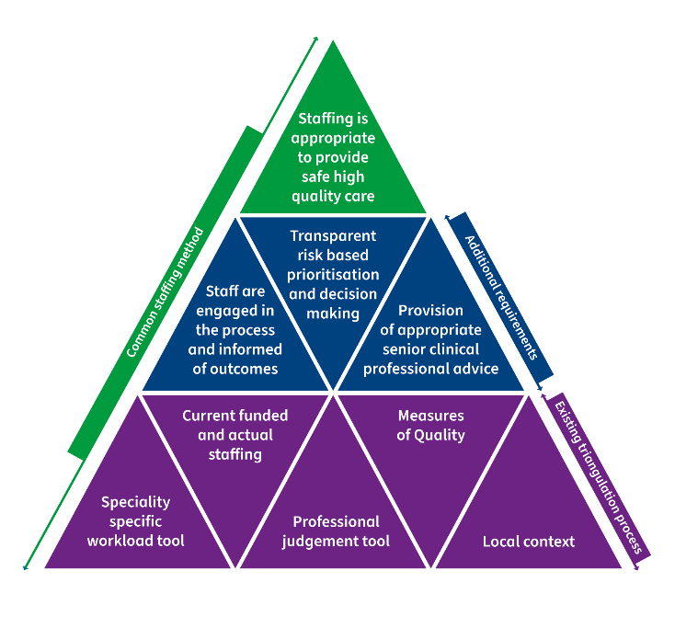
Common Staffing Method
Although the mandatory use and associated reporting requirements of the CSM only apply to the listed staff groups and areas of health care, other staff groups and areas of health care can use the principles and elements to plan and manage staffing, along with preparing for possible future extension of the CSM into their specific areas.

Professional Judgement Tool
The Professional Judgement tool is part of the national triangulation process for nursing and midwifery workload planning. It can be used in conjunction with other tools. The Professional Judgement tool can also be used by services who do not have a specialty-specific workload tool.
The Professional Judgement Tool is based on users’ professional opinion as to how many staff, registered and unregistered, are needed to carry out the workload required in a defined time.
You can find out more about the Professional Judgement Tool on Healthcare Improvement Scotland website.

Six Steps Methodology to Integrated Workforce Planning
“At its simplest, effective workforce planning ensures you will have a workforce of the right size, with the right skills, organised in the right way, within the budget you can afford, delivering services to provide the best possible patient care”. (Skills for Health & Workforce Projects Team, 2008)
The six step methodology guide identifies elements that should be in any workforce plan and can support your understanding of wider aspects to consider.
The Six Steps methodology
Step 1  Defining the Plan | Identify why a workforce plan is needed and for whom it is intended.
Step 2  Mapping Service Change | Identify the purpose and shape of any proposed service change that will impact on future workforce requirements.
Step 3  Defining the Required Workforce | Identify the skills required and the type/number of staff to deliver the new service model (workforce demand).
Step 4  Understanding Workforce Availability | Identify current and future staff availability based on current profile and deployment (workforce supply).
Step 5  Developing an Action Plan | Plan to deliver the required workforce (new skills in new locations) and manage the change.
Step 6  Implement, Monitor and Refresh | Implement the plan, measure progress and refresh the plan as required.

You can find out more about the six steps methodology here: Six-Steps-Methodology-to-Integrated-Workforce-Planning.pdf (scot.nhs.uk)
(Skills for Health & Workforce Projects Team, 2008)

Delegation
Using the NMAHP Development Framework can help to define the scope of practice for HCSWs within a team and make sure that safe and appropriate delegation takes place.
The resource Making Delegation Safe and Effective; A Learning Resource for Nurses, Midwives, Allied Health Professionals and Healthcare Support Workers, accessible on Turas Learn and the Northern Ireland Practice and Education Council for Nursing and Midwifery (NIPEC) Decision Framework for Delegation of Nursing and Midwifery Tasks and Duties are tools to support safe and effective decisions to delegate or accept delegated tasks and duties.
Regulators, for example the Nursing and Midwifery Council (NMC) or the Health and Care Professions Council (HCPC) provide guidance and standards relating to delegation which should be adhered to when considering HCSW development.
Other useful resources on delegation can be accessed via the Healthcare Improvement Scotland Safe and Effective Staffing Learning Community.

Local contact details
It would be helpful to identify the Workforce Lead in your area. Make a note of their contact details below. The Workforce Lead is a valuable source of workload and workforce planning advice and has knowledge of The Health and Care Staffing Legislation (staffing) (Scotland) Act 2019.
Board contact details:

NMAHP Professional Workforce Needs Analysis Tool
(Healthcare Support Workers)

Changes in demography and patterns of health and illness, reducing inequality, an ageing skilled and experienced workforce are only some of the factors that impact on future service needs and delivery. This information is therefore important in assessing the need for Healthcare Support Worker (level 2), Senior HCSW (level 3) and Assistant Practitioner roles (level 4) and building a robust case in support of your proposals.

Section A – Patient/Client Needs

What are the changes in the care needs and presentation of patients/clients that impact on future service needs, delivery and workforce? This may include changes in demography and patterns of health and illness; acuity, dependency, and activity, and reducing inequality.

1. What are the changes and/or challenges that currently exist in meeting patient needs?

2. How would you propose to meet these using a Healthcare Support Worker role?

Section B – Service / Speciality Skills Needs

Current models of care and workforce requirements

3. What does the current model of care look like, including current skill mix? How it is delivered and by whom?

4. What are the skills deficits, opportunities and hard to fill vacancies in the current model of care? What will be the proposed new skill mix?

5. Identify the key skills you expect the Healthcare Support Worker/Assistant Practitioner to meet.

Communication with Stakeholders
6. Who are the stakeholders who need to be involved in considering these options, for example, patients/carers, staff, staff side partners, mentors, assessors, practice supervisors, service planners?

7. How will you engage and involve key stakeholders to ensure ownership and support for the new role?

Workforce Planning

8. Has the new role been considered in the funding of the wider context of workforce planning, service planning and business planning?

9. How does the role contribute to the priorities of the organisation in terms of service delivery?

10. Could service gaps/skills deficits be addressed by using existing roles or staff in post/available to recruit? Please give a rationale.

11. How will funding implications be addressed?

12. Who will be responsible for developing the business case for sustaining the new role?

Section C – Healthcare Support Worker/Assistant Practitioner Role
This section will help to determine the type of role that is required, what the person needs to be able to do, the parameters of the role, skills, knowledge and education required and levels of accountability and responsibility.

Define New Model of Care and Healthcare Support Worker/Assistant Practitioner role

13. What new care practices and care delivery strategies can be employed to achieve identified goals? What evidence-based data supports these changes/benchmarking form learning in other Wards, Services or Boards?

14. Are changes to current roles and responsibilities required to implement new care practices and care delivery strategies?

15. What knowledge/skills will be required to deliver desired service/outcomes for patients?

16. Which professionals already have the required knowledge/skills – what limits them delivering this/benefit of new role to complement existing workforce?

17. Would the new role enhance ability to achieve goals for meeting patient health care needs? How do you know this?

Parameters of accountability
18. Have you defined specific areas of accountability for the individual/s taking on this role?

19. Do you have team roles and systems that support the individual’s accountability e.g. scheme of delegation?

20. Do you have mechanisms in place for support and supervision?

21. Have the scope of practice and the limitations of the new role been clearly identified, in line with the organisation’s risk management policy and procedures and vicarious liability?

22. Have the activities of the new post holder been identified reflected in agreed core JD?

23. How will you ensure the role is sustainable and not person dependent for example who will cover the role in case of absence/sickness?

24. Who will the practitioner be accountable and responsible to on a daily basis?

Governance arrangements
25. Have clinical and professional accountability and supervision been agreed?

26. What arrangements have been made to support the new role in terms of supervision?

27. What mechanisms are in place to ensure individuals maintain their skills and competence?

28. Have the skills and competences required for the new or enhanced role been identified? Have they been mapped to any existing national standards?

Evaluation/succession planning

29. How will you measure the impact of new roles in your area, this should include feedback from key stakeholders and individuals undertaking the new roles?

Healthcare Support Worker Service Needs Analysis
Board Area
SNA agreed and signed by:

 | Print and Sign | Date
SCN/M, Team Leader:
Senior/Lead Nurse / Midwife / AHP:
SNA agreed and signed by:

Nurse Director / AHP Director

Developed December 2022. Based on existing service needs analysis tools provided by NHS Lothian and Tayside. Acknowledgement of Health Improvement Scotland and Short Life Working Group contributions to this document.

